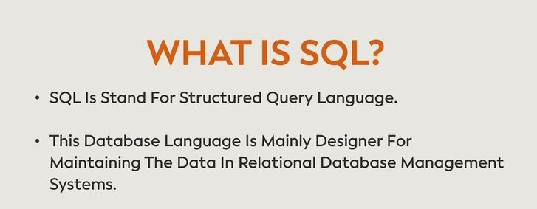
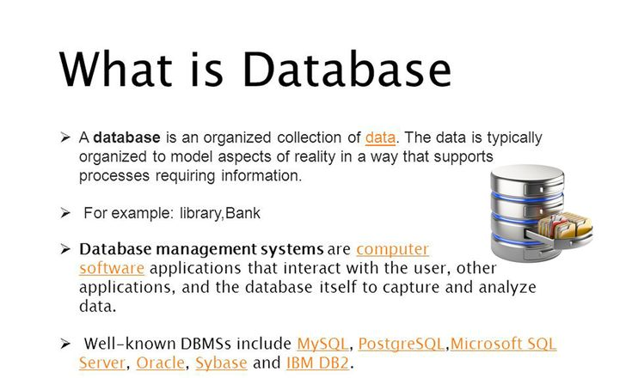
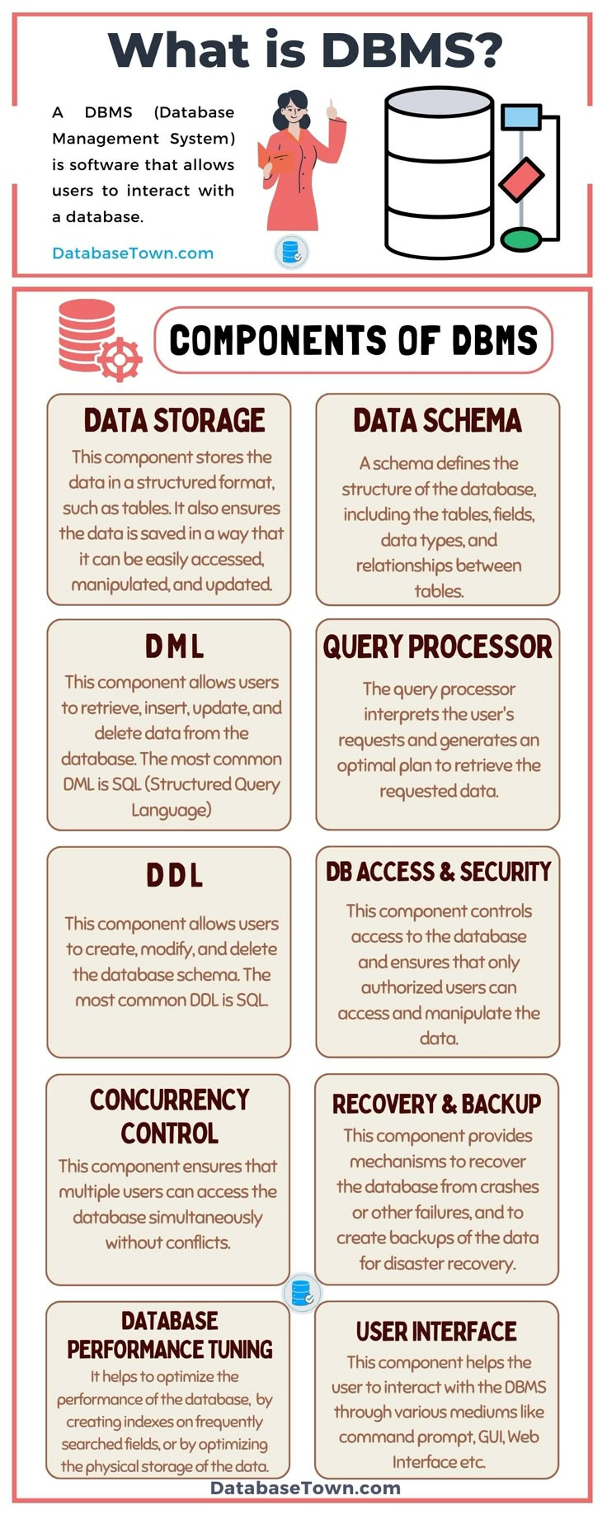

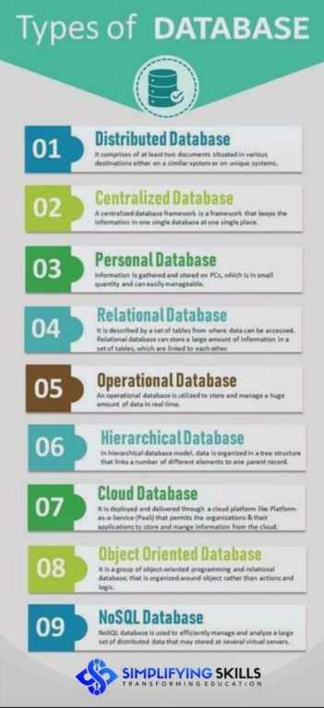
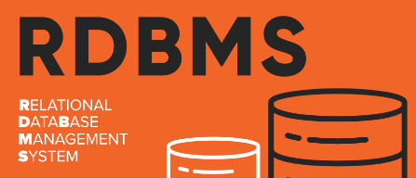
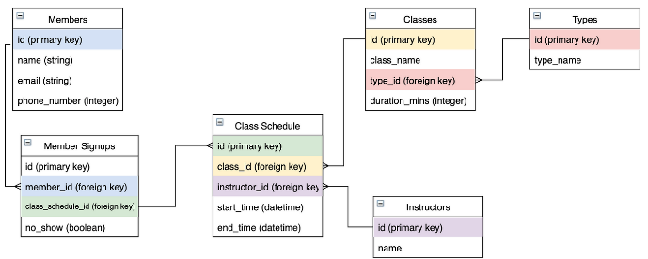
A software system that enables you to define, create, maintain, and control access to relational databases. It is the underlying part of the interface layer that helps you store and work with data.

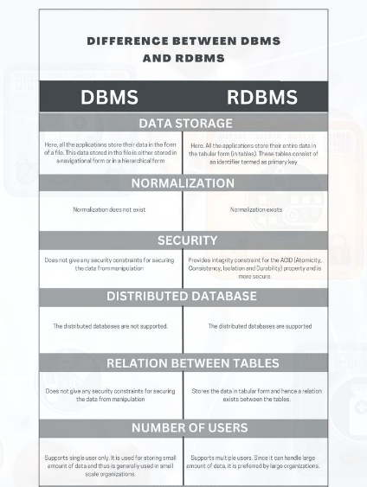
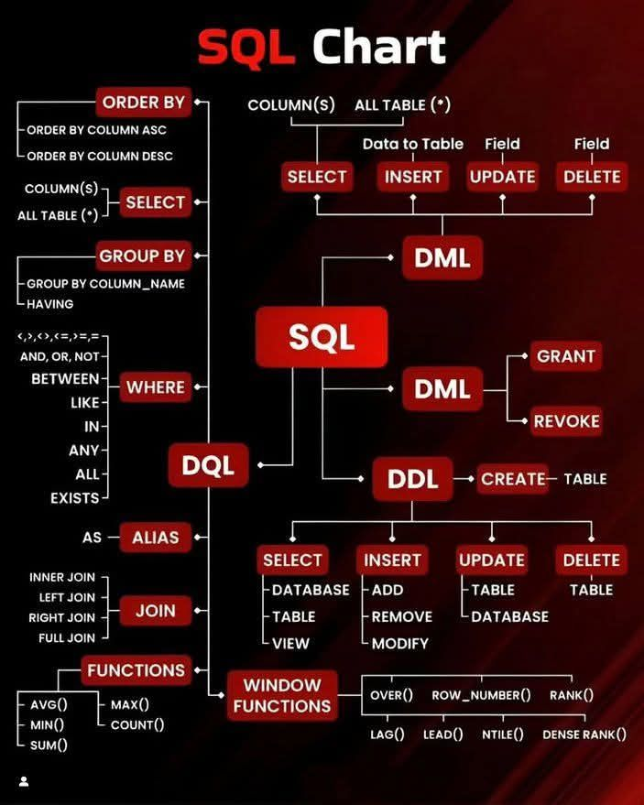
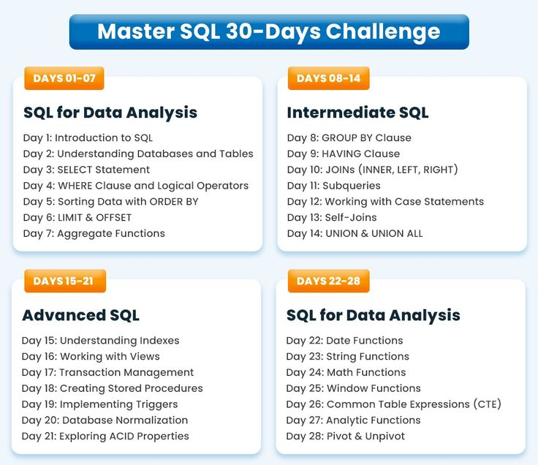
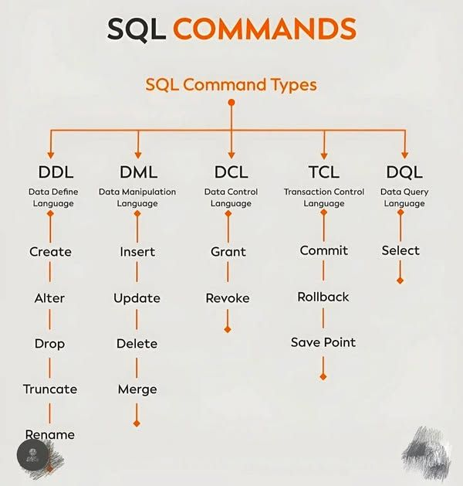

Relational Database Management Systems

Database - A database is an organized collection of structured information, or data, typically stored electronically in a computer system.
DBMS - A DBMS is a software system that allows users to define, create, maintain, and control access to the database.
Role of DBMS:
- Manages the database structure.
- Controls access to data.
- Ensures data integrity and consistency.
- Handles data storage and retrieval.
- Provides backup and recovery mechanisms.
What is the "Relational" in RDBMS?
This is the core concept. Data is organized into tables (also called "relations"), where each table consists of rows and columns.
Data within different tables can be related to each other based on common fields (columns). This ability to establish links between tables is what makes it "relational."
Types of SQL commands:

Creating and Managing Databases

CREATE DATABASE - The CREATE DATABASE statement is a DDL command used to create a brand new, empty database in MySQL.
CREATE DATABASE database_name;

Rules to create new database
- Must be unique within the MySQL server instance.
- Can contain letters (a-z, A-Z), digits (0-9), and underscores (_).
- Cannot contain spaces or special characters (except underscores).
- Maximum length is 64 characters.
- Case sensitivity depends on the operating system (e.g., case-sensitive on Linux, case-insensitive on Windows).
- Avoid reserved words (e.g., SELECT, TABLE) unless enclosed in backticks (`).
Examples of valid names: hospital_db, patient_records_2025, my_database

  - USE database_name; statement.
  - SHOW DATABASES; statement.
DROP DATABASE statement
It is important to make sure that we have to perform the backup of the database that we are going to delete because once the "DROP DATABASE" statement is executed, all the data and database objects in the database will be permanently deleted and cannot be recovered

Suppose there is an existing database in MySQL with the name upgrad and if we try to create another database with the same name. it will give you an error
In that case we use-

CREATE DATABASE IF NOT EXISTS Database_name;

Data Definition Language (DDL) - Building the Structure

  - CREATE TABLE statement.
  - Data Types in MySQL:
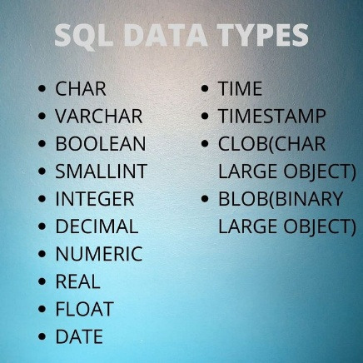
Decimal (M,D)
M - This represents the total number of digits that can be stored, both before and after the decimal point. The range for M is 1 to 65.
D - This represents the number of digits that can be stored after the decimal point
Example - price DECIMAL(7, 2)
numbers like 12345.67, 99999.99, or 123.45

CREATE TABLE table_name ( column1_name DATATYPE, column2_name DATATYPE, ... columnN_name DATATYPE );

  - Constraints:
Constraints are rules applied to columns.
Their primary goal is to maintain the accuracy, reliability, and consistency (integrity) of the data in the database.

    - NOT NULL
    - UNIQUE
    - PRIMARY KEY (composite primary keys)
    - FOREIGN KEY (referential integrity)
    - DEFAULT
    - CHECK

Primary key v/s unique constrain
Primary Key:
- Uniquely identifies each row in a table.
- It cannot be NULL and there can be only one primary key per table.
- Its main purpose is to ensure data integrity and establish relationships between tables.
Unique Key:
- Ensures that all values in a column (or set of columns) are unique.
- It can allow NULL values and there can be multiple unique keys per table.
- Its main purpose is to prevent duplicate data in specific columns.

Primary key - When you define a primary key ,automatically creates a index on that column .
This means that the actual physical order of the data rows on the disk is organized based on the primary key's values. This makes data retrieval (especially lookups and range scans) using the primary key extremely fast because the database can directly go to the physical location of the data.

CREATE TABLE Customers ( customer_id INT PRIMARY,
first_name VARCHAR (50) NOT NULL, -- ------First name cannot be NULL
last_name VARCHAR (50) NOT NULL, --------- Last name cannot be NULL
email VARCHAR (100) UNIQUE -------------- Email must be unique, but can be NULL
price DECIMAL (10, 2) CHECK (price > 0), ------------- Price must be greater than 0
state VARCHAR (20) DEFAULT 'Odisa', -------------- -- Default state is 'odisa'

-- Define the Foreign Key
FOREIGN KEY (foreign_key_column) REFERENCES parent_table_name (parent_primary_key_column);

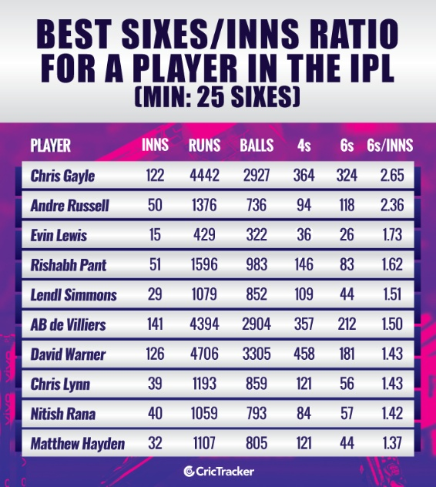

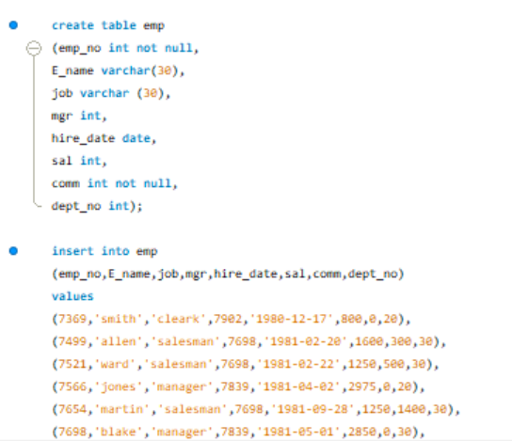

ALTER Command
ALTER command is used to modify the structure of an existing table. It allows you to make various changes, such as adding, deleting, or modify columns within the table.
ALTER interacts with the structure of a table to modify it, UPDATE only interacts with the data present in the table without disturbing its structure.
- Adding a column
- Dropping a column
- Altering the column’s Name or Definition
- Altering table’s Name
Adding a column
To add a new column into an existing table, we use ADD keyword with the ALTER TABLE command.

ALTER TABLE CUSTOMERS ADD ID INT;

Dropping a column
ALTER TABLE customers DROP COLUMN email;
Altering the column’s Definition
ALTER TABLE table_name
MODIFY COLUMN column_name new_datatype [constraints];

Rename a Table
ALTER TABLE old_table_name RENAME TO new_table_name;
Change a Column name
- ALTER TABLE employees CHANGE COLUMN old_name new_name VARCHAR (255);
- ALTER TABLE table_name RENAME COLUMN old_column_name TO new_column_name;
Adding a Primary Key
ALTER TABLE table_name ADD PRIMARY KEY (col_name);
Dropping a Primary Key
ALTER TABLE table_name DROP PRIMARY KEY;

Data Manipulation Language (DML) - Working with Data

Inserting Data
INSERT INTO table_name VALUES (value1, value2, value3, ...);
- INSERT INTO students (first_name, last_name, age) VALUES ('Alice', 'Smith', 20);
- INSERT INTO
Students
(first_name, last_name, age)
VALUES
('Charlie', 'Brown', 21),
('Diana', 'Prince', 23),
('Eve', 'Adams', 19);


Filtering Data (WHERE clause)
    - Comparison operators (=, !=, <, >, <=, >=)
    - Logical operators (AND, OR, NOT)
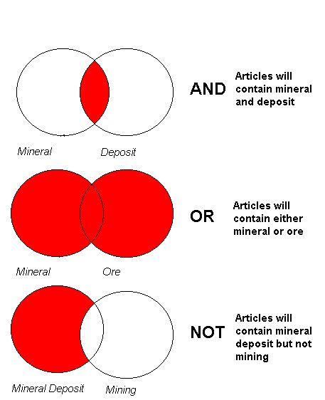
    - IN and NOT IN operators.
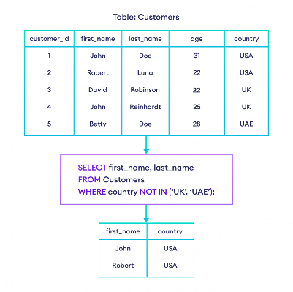
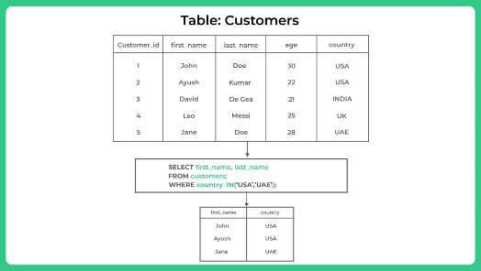
    - BETWEEN and NOT BETWEEN operators.
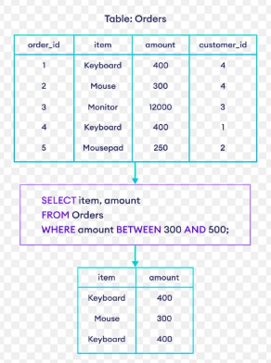
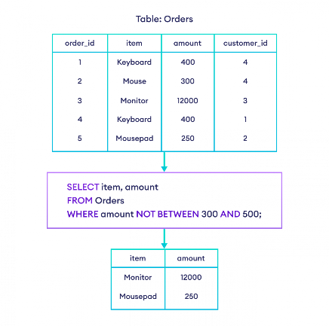
    - LIKE and NOT LIKE operators (wildcards: %, _).
The LIKE operator in SQL is used to search for a specified pattern in a column.
SELECT ProductName FROM Products WHERE ProductName LIKE 'Lap%';
SELECT ProductName FROM Products WHERE ProductName LIKE '%PC';
SELECT ProductName FROM Products WHERE ProductName LIKE '%Mo%';
SELECT ProductName FROM Products WHERE ProductName LIKE '_i%';
SELECT ProductName FROM Products WHERE ProductName NOT LIKE '%Wireless%';
WHERE ProductName LIKE 'a%b';
WHERE ProductName LIKE '2_ _ _3'

- Retrieving Data (SELECT Statement - The Core!):
- all the information of the EMP table?
- Show employee name and their job
- Display unique Jobs from EMP table?
- Merge any two columns.
- List the emps in the ascending order of their Salaries?
- List the emps in the descending order of their Salaries?
- List the emps name only in the ascending / descending order of their Salaries?
- List the emps name with salary in the ascending / descending order of their Salaries?
- Show top 5 employee according to their salary
- Show least 5 employee according to their salary
- Show all info of Mgr 7369.
- Display the name and job of the employee who has salary 5000?
- Display the name and job of the employee who has salary greater than 1600?
- Display the name and job of the employee who has salary less than 1800?
- List the emps who joined before 1981.
- List the emps who are joined in the month of Aug and 1980.
- List the Empno, Ename, Sal, Daily sal of all emps in the asc
- List the Empno, Ename, annual package of all emps in the asc
- Show top 5 package holder
- Display the Empno, Ename, job, Hiredate, where Mgr no is 7698.
- Show the experience of all mgrs.
- List the Empno, Ename, Sal, Exp of all emps working for Mgr 7369.
- List the emps along with their Exp and Daily Sal is more than Rs.100.
- List the emps who are joined in the year 81.

Between/ not between

SELECT column_name(s)
FROM table_name
WHERE column_name BETWEEN value1 AND value2;

- Select all employees whose salary is between 1000 and 2000 (inclusive).
- List the emps Who Annual sal ranging from 22000 and 45000.
- Find all employees who were hired between January 1, 1981, and December 31, 1981 (inclusive).
- Retrieve employees whose employee number (emp_no) is between 7500 and 7800.
- Find employees whose salary is between 2500 and 3000 AND who belong to department 20 or 30.
- Select all employees whose salary is NOT between 1000 and 2000.
- Retrieve employees whose employee number (emp_no) is NOT between 7500 and 7800.
- Find employees whose salary is NOT between 2500 and 3000 OR who do NOT belong to department 20 or 30.

In/not in

- Select all employees who work in department numbers 10, 20, or 40.
- Find all employees whose job title is 'SALESMAN' or 'MANAGER'.
- List employees whose name is 'SMITH', 'ALLEN', or 'KING'.
- Retrieve employees who were hired on '1981-12-17' or '1982-01-22'.
- Find employees with employee numbers (emp_no) 7369, 7566, or 7839.
- Find all employees whose job title is NOT 'SALESMAN' or 'MANAGER'
- List the emps who joined on 1-MAY-81,3-DEC-81,17-DEC-81,19-JAN80 in asc order of seniority.
- list all the emps except ‘PRESIDENT’ & “Manager” in asc order of Salaries.
- List the emps who does not belong to Deptno 20.
- List all the emps who joined before or after 1981.
- List the emps who joined in any year but not belongs to the month of March.

And / or
- List the emps who are either ‘CLERK’ or ‘ANALYST’ in the Desc order.
- List the emp who are working for the Deptno 10 or 20.
- Select all employees who are 'SALESMAN' AND have a salary greater than 1500.
- Find employees who have a commission (comm) of 0 AND work in department 20.
- List employees who were hired in '1980' OR in '1983'.

Like (%,_)

- List the Enames those are having five characters in their Names.
- List the Enames those are starting with ‘S’ and with five characters.
- List the emps those are having four chars and third character must be ‘r’.
- Retrieve employees whose name ends with 'N'.
- List jobs that contain 'LE'.
- Find employees whose name has 'A' as the second letter.
- List employees whose job has 'S' as the third letter.
- Find employees whose name starts with 'J' AND their job starts with 'C'.
- List employees whose name contains 'AR' OR their job is 'ANALYST'.
- List jobs that do NOT contain 'ER'.
- Find employees whose name starts with 'S' and their salary is greater than 1000.
- List employees whose job contains 'MAN' and they were hired in 1981.
- Retrieve all employees whose name starts with 'M' and order them by hire_date in ascending order.
- List all jobs that contain 'ER' and order them alphabetically.
- Find employees whose name starts with 'C', followed by any two characters, then 'R'.

- List the Five character names starting with ‘S’ and ending with ‘H’.
- List the emps whose Sal is four digit number ending with Zero.
- List the emps whose names having a character set ‘LL’ together.
- List the emps whose Empno not starting with digit 78.

String and Date
- UPPER(str) → Converts string to uppercase
- LOWER(str) → Converts string to lowercase
- LEFT(“rama”, 2) → Returns first n characters from the string
- SUBSTRING(str, start, length) → Extracts part of string from given position

- Display the employee name, job, and hire date in the following format: Smith was hired on 17 December 1980 (Use proper capitalization and date formatting)
- List all employees who were hired in the year 1981. Show employee number, name, job, and hire date.
- Display the employee name, hire date, and the day name (like Monday, Tuesday, etc.) on which they were hired. Sort by hire date.
- Find the number of years each employee has completed since their hiring date (as of today). Show employee name, hire_date, and years of service.
- Show all employees whose name starts with 'S' or ends with 'S'. Display name and job.
- Display the department name and location in uppercase, along with the length of the department name.
- List employees hired between February 1981 and June 1981 (inclusive). Show name, job, and hire_date in dd-Mon-yyyy format.
- For each employee, show their name and the number of months they have worked in the company (as of current date). Round to the nearest whole number.
- Display employee name and job, but replace the word "cleark" with "clerk" (correct the spelling) in the output.
- Show the employee name, salary, and commission. If commission is 0, display "No Commission" instead of 0. Also format the hire date as Month DD, YYYY.
- Find employees who were hired on a Wednesday. Show their name, hire_date, and day name.
- Display the last 3 characters of each employee's name and the first 3 characters of their job title. Combine them with a hyphen (e.g., ith-ana).
- Calculate the tenure of each employee in years and months. Example output: Scott has been working for 43 years and 4 months
- List all employees from the Research or Sales department. Show employee name, department name, and location. (Join both tables)
- Create a report showing: Employee Name (in Proper Case), Job (in Uppercase), Hire Date in DD/MM/YYYY format, and the number of days since they were hired.

Basic Aggregate Functions
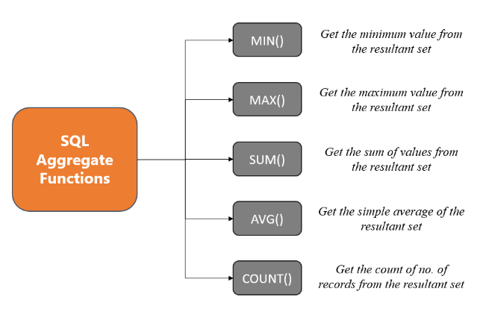

- Count the total number of employees.
- Find the average salary of all employees.
- Determine the highest salary among all employees.
- Determine the lowest salary among all employees.
- Calculate the sum of all salaries paid to employees.
- How many employees are there in total?
- How many employees are in department 20?
- How many distinct job titles are there?
- What is the total salary paid to all employees?
- What is the total commission paid to all employees?
- What is the total salary for employees in the 'SALESMAN' job role?
- What is the average salary of all employees?
- What is the average salary in department 30?
- What is the average commission for 'SALESMAN's?
- What is the lowest salary in the company?
- What is the minimum salary in department 10?
- What is the highest salary in the company?
- What is the maximum salary among 'MANAGER's?

Group by
The `GROUP BY` clause in MySQL is used to arrange identical data into groups. It is commonly employed with aggregate functions (like `COUNT`, `SUM`, `AVG`) to perform calculations on each group of data.
The `GROUP BY` clause is used when you need to aggregate data and group rows that have the same values in specified columns. It follows the `FROM` and `WHERE` clauses in a SQL query.

SELECT column1, aggregate_function(column2)
FROM table_name
[WHERE condition]
GROUP BY column1;

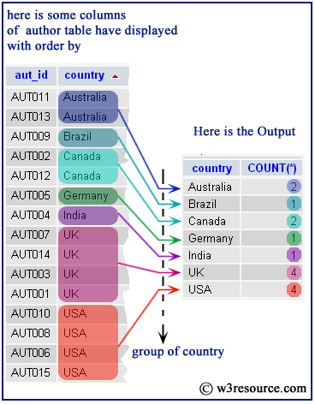
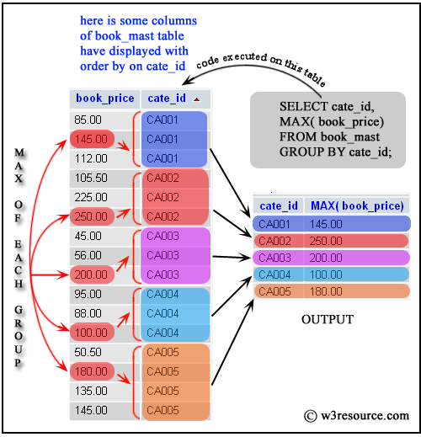
- Count the number of employees in each department.
- Find the average salary for each job title.
- Determine the maximum salary paid in each department.
- Calculate the total sum of salaries for each job title.
- Count how many employees were hired in each year.
- Count the number of employees for each job title within each department.
- Find the average salary for each job title within each department.
- Count the number of 'SALESMAN' in each department.
- Count the number of employees whose name starts with 'S' for each department
- Find the average salary and number of employees hired after '1981-06-01' for each department.
- Determine the maximum salary for 'ANALYST' and 'MANAGER' job roles, grouped by department.
- Calculate the total salary for employees with a salary greater than 2000, grouped by job title.

GROUP BY with HAVING
The HAVING clause is used with the GROUP BY clause in a query to specify come conditions and filter some groups or aggregates that fulfill those conditions.

WHERE
SELECT

GROUP BY
HAVING

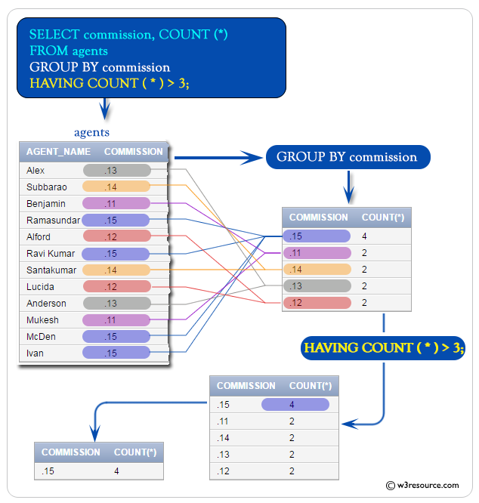
SELECT column1, column2, …
FROM table_name
WHERE conditions
GROUP BY column1, column2, …..
HAVING conditions ;

- List departments that have more than 3 employees.
- Show departments where the total salary expense is less than 9000.
- Identify job titles that have at least 2 employees and whose maximum salary is over 3000. . s
- List managers who manage exactly 3 employees.
- Find the job titles where the average salary of employees hired in 1981 is greater than 2000.
- Show the average salary for each department, but only for departments where the lowest salary is above 1000 and the department has more than 2 employees.
- Count the number of 'SALESMAN' in each department
- Find the average salary of 'MANAGER's in departments where the total salary for managers is over 2500.

Window function
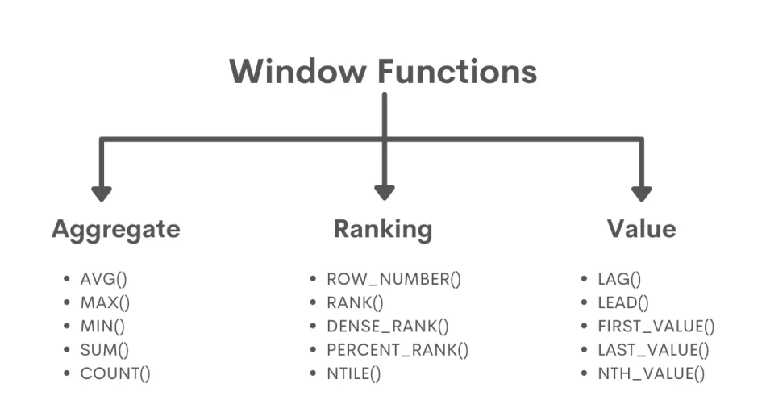
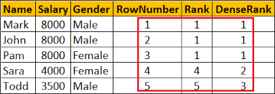

Window functions are a powerful feature in SQL that perform calculations across a set of table rows that are related to the current row. Unlike aggregate functions (like SUM(), AVG(), COUNT()) which condense rows into a single output row, window functions return a value for each row in the result set.
Concept of Frame
within that window, the FRAME is a smaller, moving sub-window that determines which rows are considered for the calculation of the window function for the current row you are processing
- UNBOUNDED PRECEDING: Represents the start of the partition or window frame, encompassing all rows from the beginning of the partition up to the current row.
- N PRECEDING: Encompasses ‘n’ rows before the current row. If ‘n’ is a positive integer, it includes that number of preceding rows. If ‘n’ is zero, it includes only the current row.
- CURRENT ROW: Represents the current row being processed.
- M FOLLOWING: Encompasses ‘n’ rows after the current row. If ‘n’ is a positive integer, it includes that number of following rows. If ‘n’ is zero, it includes only the current row.
- UNBOUNDED FOLLOWING: Represents the end of the partition or frame, including all rows from the current row to the end of the partition.
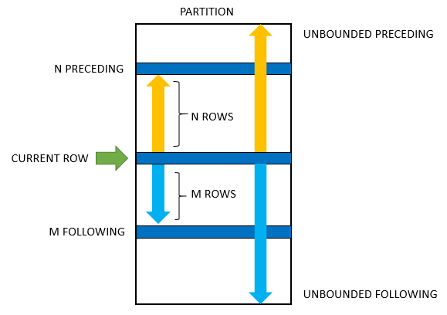

ROWS BETWEEN
The ROWS BETWEEN clause defines the range of rows based on the row count, not on the values themselves. It specifies a fixed number of rows before and/or after the current row within the partition.
Example:
- ROWS BETWEEN 3 PRECEDING AND CURRENT ROW; this frame starts 3 rows before the current row and ends on the current row. Hence, the frame has 4 rows.
- ROWS BETWEEN 1 PRECEDING AND 1 FOLLOWING; this frame starts 1 row before the current row and ends one row after the current row. Hence, the frame has 3 rows.
- ROWS BETWEEN 5 PRECEDING AND 1 FOLLOWING; this frame starts 5 rows before the current row and ends one row before the current row. Hence, the frame has 5 rows.
- 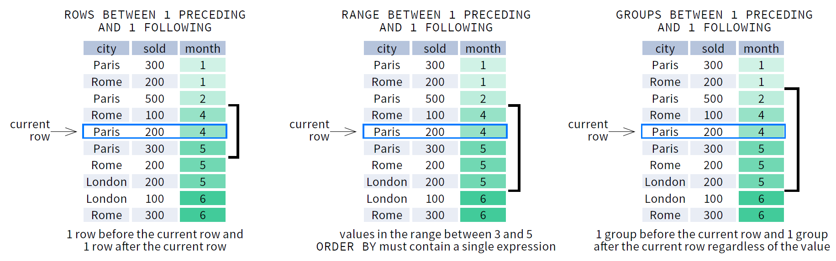
- 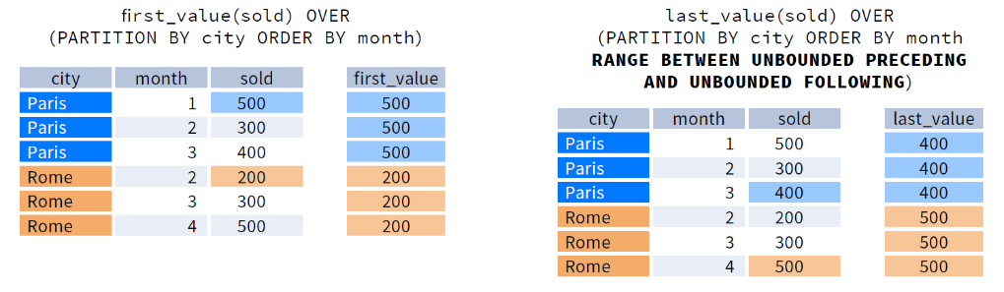
RANGE BETWEEN:

The RANGE BETWEEN clause defines the range of rows based on the values of the data within the rows, not on the row count. It includes rows whose values fall within a specified range relative to the current row.
Example:
- ROWS BETWEEN UNBOUNDED PRECEDING AND CURRENT ROW; specifies that the range includes all rows from the beginning of the partition up to and including the current row.[by default]
- ROWS BETWEEN CURRENT ROW AND UNBOUNDED FOLLOWING; specifies that the range includes the current row and all rows following it within the partition.
- ROWS BETWEEN UNBOUNDED PRECEDING AND UNBOUNDED FOLLOWING; specifies that the range includes all rows within the entire partition.
- RANGE BETWEEN 10 PRECEDING AND 5 FOLLOWING; this includes rows whose values fall within 10 above or below the current row’s value.
- Rows between 1 preceding and 1 following – CURRENT row with row immediately before and after
ROWS BETWEEN UNBOUNDED PRECEDING AND CURRENT ROW
- 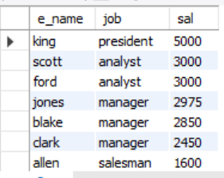
First value
Range = Current value + first value

L

Range = current + last value
Last Value

ROWS BETWEEN UNBOUNDED PRECEDING AND UNBOUNDED FOLLOWING

Last value
Range = [1st row to last row]

LAG(): Looking Backwards

lets you access a value from a row before the current row within your defined window.
Example- You're reading a book, and you want to remember what was written on the previous page.

LEAD(): Looking Forwards
LEAD() lets you access a value from a row after the current row within your defined window.
Example- You're reading a book, and you want to see what will be written on the next page.
LAG() and LEAD() Questions
- For each employee, display their salary and the salary of the employee hired immediately before them (based on hire date).
- For each employee, display their salary and the salary of the employee hired immediately after them (based on hire date).
- Calculate the difference in salary between an employee and the employee hired immediately before them within the same department.
- Identify employees whose salary is higher than the employee hired immediately after them within the same department.
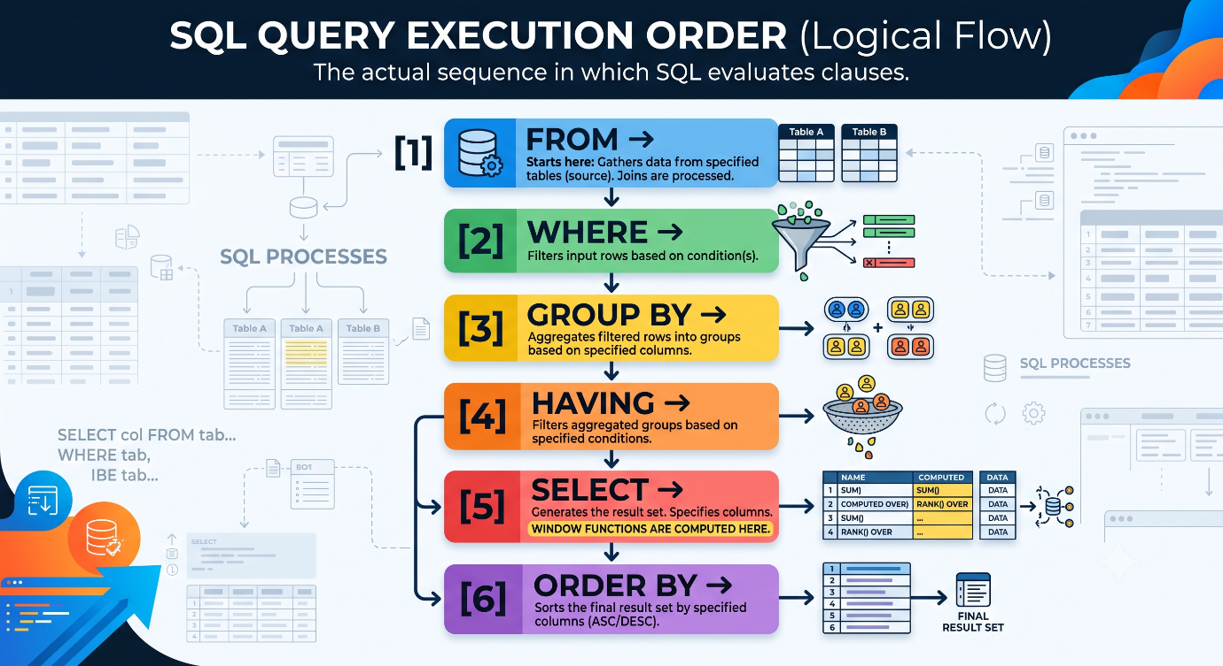

1. FROM → grab the raw data
2. WHERE → throw out rows you don't want
3. GROUP BY → bundle rows into groups
4. HAVING → throw out groups you don't want
5. SELECT → decide what columns to show (window functions happen HERE)
6. ORDER BY → sort the final list

Simple rule: you can't use something before it's been made.
Three types of functions, three "stations" on the line
1. Plain functions (ROUND(), UPPER()) — need nothing extra, just the row itself.
→ Can be used anywhere, even at station 2 (WHERE).
2. Aggregate functions (SUM(), AVG(), COUNT()) — need groups to already exist.
→ Only usable from station 4 (HAVING) onward. Can't use in WHERE (station 2) because groups aren't made yet.
3. Window functions (RANK(), LAG(), anything with OVER()) — need to know the final list of rows to rank/compare them.
→ Only usable at station 5 (SELECT) or 6 (ORDER BY). This is the last station they can be built at, because they need to see everything that survived filtering first.
Window functions are built near the end of the line (SELECT), but WHERE checks happen near the start — so WHERE can never see a window function's result directly. Wrapping it in a subquery lets one line finish before the next one starts.

(Understanding OVER(), PARTITION BY, ORDER BY)
- Display all employees with their salary and the total salary of all employees using a window function.
- Show employee details along with their department's total salary.
- List all employees with their salary and the average salary of their own department.
- Display emp_no, E_name, sal, and the maximum salary in their department.
- Show each employee’s salary and the minimum salary in their department.
- For each employee, show how much more/less they earn compared to the average salary of their department (difference = sal - avg_sal_dept).
- Rank employees within the entire company by salary in descending order (use RANK()).
- Do the same as above but use DENSE_RANK() — observe the difference.
- Do the same using ROW_NUMBER().
- Assign row numbers to employees ordered by hire_date (earliest first).

(Multiple scenarios)
- Show employee name, job, salary, and their rank within their job category by salary descending.
- Find the 2nd highest salary in each department using window functions.
- Find the top 3 highest-paid employees in the company using window functions.
- Show each employee’s salary and the salary of the next employee when ordered by emp_no.
- Show each employee’s salary and the salary of the previous employee when ordered by hire_date.
- Calculate the running total (cumulative sum) of salaries when employees are ordered by hire_date.
- Calculate running total of salary within each department, ordered by hire_date.
- Show each employee’s salary and what percentage their salary is of the total company salary.
- For each department, show each employee’s salary and what percentage it is of their department’s total salary.
- Number the employees within each job title (e.g., all clerks get 1,2,3… separately).
- List employees along with how many people joined on the same hire_date.
- Show the latest hire_date in each department and compare each employee’s hire_date with it.
- Use NTILE(4) to divide employees into 4 salary quartiles across the company.
- • Find the employee with the highest salary in each department without using GROUP BY (only window functions).
- • Show for each employee: their salary, department average, and how many people in their dept earn more than them.
- • Moving average: Show 3-person moving average of salary when ordered by hire_date.
- • Find salary gaps: difference between current employee’s salary and the next higher salary in the same department.
- • Show the first and last salary when employees are ordered by emp_no using FIRST_VALUE() and LAST_VALUE().
- • Compare each employee’s salary with the very first (earliest hired) employee’s salary in their department using FIRST_VALUE().
- • Calculate the cumulative count of employees hired over time (ordered by hire_date).
- • Show department name, employee name, salary, and the rank of the department by total salary (department-level ranking).

Join
It's crucial to have efficient methods that enable users to extract records from two or more tables based on specific criteria.
Different types of JOINs in MySQL
- INNER JOIN returns rows with matching values across all specified tables.
- LEFT JOIN includes all rows from the left table and only matching rows from the right table. Non-matching rows from the right table are filled with NULLs.
- RIGHT JOIN returns all rows from the right table and only the rows from the left table that meet the JOIN condition. Non-matching rows from the left table are filled with NULLs.
- CROSS JOIN combines every row from one table with each row from another, resulting in a table with all possible row combinations.
- SELF JOIN allows comparisons within the same table or the extraction of hierarchical data. Table aliases are used here to avoid repeating the same table name.
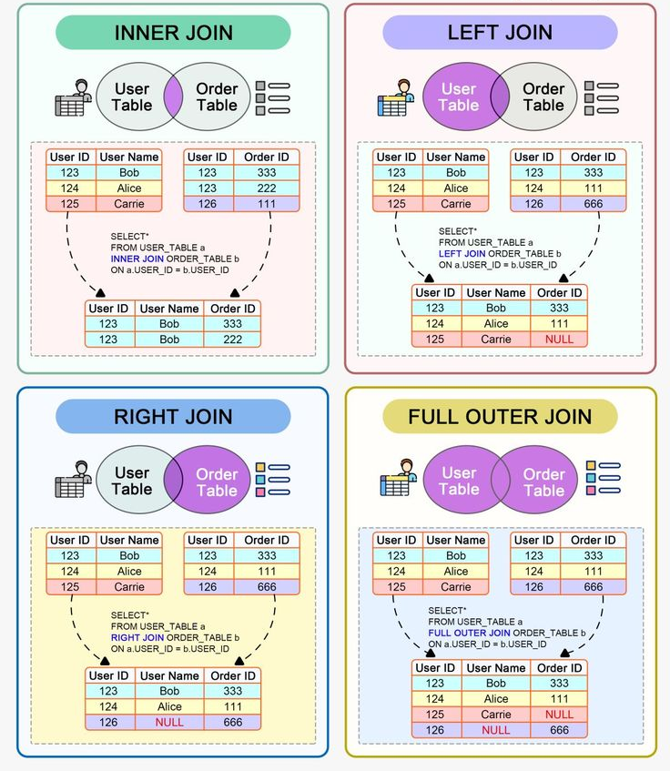
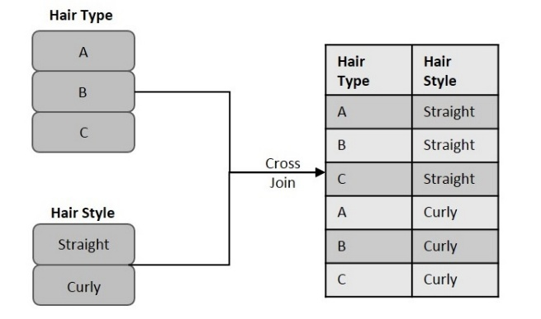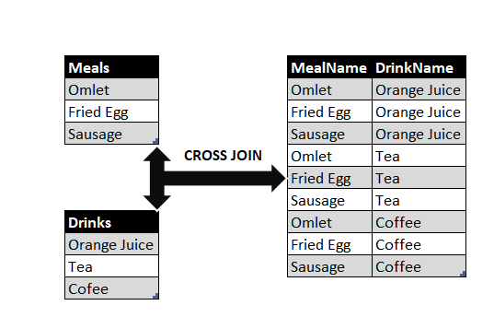

SELECT column1, column2, ...
FROM TableA
JOIN_TYPE TableB
ON
TableA.common_column = TableB.common_column;

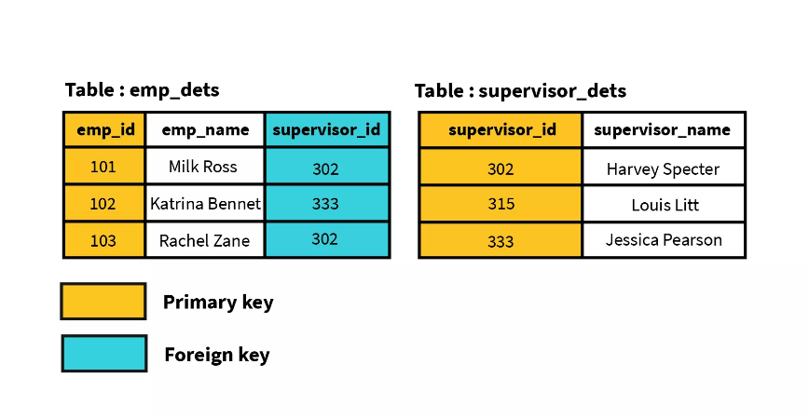

- Retrieve employee names and their corresponding department names.
- List all employees, their jobs, and the location of their departments.
- Find the names of all employees who work in the 'SALES' department.
- Show the department name and the number of employees in each department.
- Find the names of all employees who work in 'NEWYORK' and have a salary greater than 1000.
- List all salesmen who work in 'CHICAGO' and were hired after 1981.
- Show the employee number, name, and department name for employees whose commission is greater than their salary.
- Retrieve the names of employees and their department locations for employees whose job is 'ANALYST' and are in department 20.
- List all employees and their corresponding department names.
- Find the names of employees who work in the 'SALES' department.
- Show the employee number, name, job, and department location for all employees.
- List all departments and the number of employees in each department.
- Find the average salary for each department.
- List all departments, and for each department, show the employees working in it. Include departments that might not have any employees.
- Find the names of employees and their managers.
- List employees who earn more than their manager.
- For each department, list the department name, the number of employees, and the average salary. Only include departments where the average salary is above 2000.
- Find the names of employees who are 'SALESMAN' and work in 'CHICAGO'.
- Retrieve the names of employees, their jobs, department names, and location for employees who were hired in 1981.
Understanding JOIN Types
- LEFT JOIN (or LEFT OUTER JOIN): Returns all rows from the left table, and the matched rows from the right table. If there's no match, NULL values are returned for the right table's columns.
- RIGHT JOIN (or RIGHT OUTER JOIN): Returns all rows from the right table, and the matched rows from the left table. If there's no match, NULL values are returned for the left table's columns.
- FULL OUTER JOIN: Returns all rows when there is a match in either the left or right table. If no match exists for a row, the columns from the non-matching side will be NULL. (Note: Some SQL databases, like MySQL, don't directly support FULL OUTER JOIN. You'd typically achieve it using a LEFT JOIN UNION a RIGHT JOIN).
- SELF JOIN: A regular join (usually INNER JOIN or LEFT JOIN) where a table is joined with itself. This is useful when you need to compare rows within the same table, often for hierarchical data (like employees and their managers).

- Left Join Questions
- Question: List all employees, their names, and their department names. Include employees even if, hypothetically, they didn't have a department assigned (though in your current data, all employees have a department).
  - Reasoning: This is a classic LEFT JOIN scenario because you want all employees (from the emp table, which is on the left) and their matching department details.
- Question: Show all department names and the names of employees in each department. If a department has no employees, still list the department name.
  - Reasoning: You want all departments (from the dept table, which is on the left) and any associated employees. This is particularly useful if your dept table had a department with no current employees.
- Question: Display the employee's name, job, and the name of their department. Ensure all employees are listed, regardless of whether their dept_no has a corresponding entry in the dept table.
- Right Join Questions
- Question: List all department names and the names of employees in each department. Include departments that currently have no employees.
- Question: Show all department locations and the names of employees located there. Include locations even if no employees are assigned to them (e.g., if there was a loc in dept without any emp records).
  - Self Join Questions

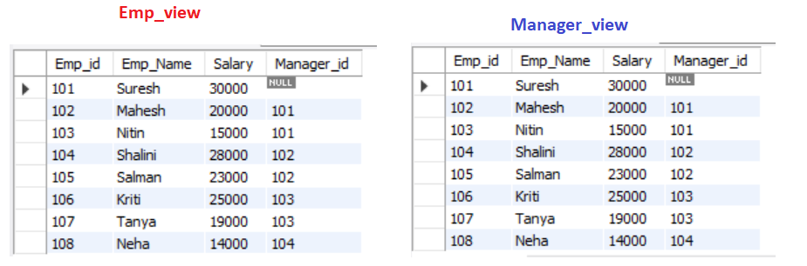
If I join emp.manager_id = manager.emp_id

- Question: Find the names of all employees and the names of their direct managers.
- Question: List the names of employees who have the same job title as their manager.
- Question: Identify pairs of employees who work in the same department. Exclude matching an employee with themselves.
- Find Employees and Their Managers in the Same Department number/ job. Correlated subqueries: These use values from the outer query's current row, running once for each row, so you can do row-by-row comparisons. For example, to get sales reps who've closed deals worth more than the average deal size for their region,

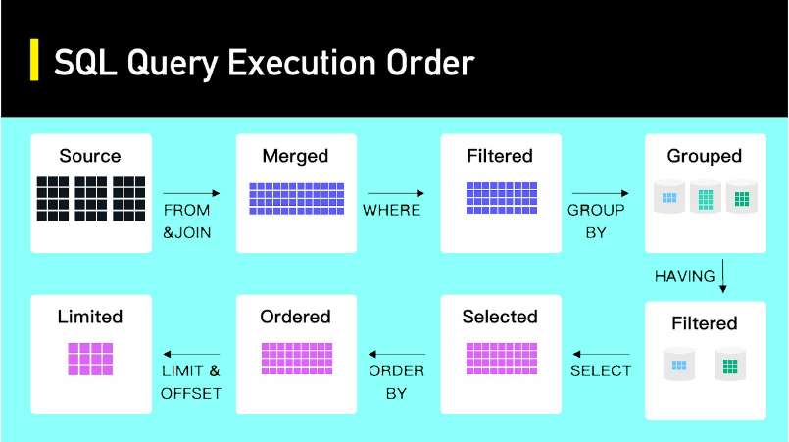

UPDATE statement with SET and WHERE clauses.
The UPDATE statement is used to update or modify data in a table.
UPDATE table_name
SET
column1=value1, column2=value2,...
WHERE condition;

SET SQL_SAFE_UPDATES = 0;

- Increase SMITH's salary to 900.
- Change ALLEN's job title to 'SENIOR SALESMAN'.
- Update WARD's commission to 700.
- Change BLAKE's department number to 40.
- Set MARTIN's manager (mgr) to 7566.
- Change SCOTT's job title to 'SENIOR ANALYST' and his department to 40.
- Set KING's hire date to '1981-12-01' and his salary to 5500.
- Give all 'SALESMAN' a 10% raise
- Increase the salary of employees in department 20 by 200.
- For employees hired in 1981, update their department to 50 if their current department is 30.
- Change the job title of employees with a salary less than 1000 to 'JUNIOR CLERK'.
- Give a 5% bonus (increase salary by 5%) to employees in department 10 or 30.
- For employees whose job is 'ANALYST' or 'CLEARK', increase their salary by 100.
- Set the comm to 0 for any employee whose job is 'MANAGER' or 'PRESIDENT' and whose sal is above 2500.
- For employee 'MARTIN', change their job to 'SALES_REP' and their salary to 1350.
- Update 'SCOTT's job to 'SR. ANALYST' and his department to 10.
- Set 'KING's commission to 1000 and his mgr to NULL (or an appropriate manager if you know one).
  - .
- Set the commission of all employees earning less than 1000 to 100.
- Reduce the salary of employees in department 20 by 5% if their salary is currently above 2000.
- For employees hired before '1982-01-01', increase their salary by 500 if their current salary is between 800 and 1500 (inclusive).
- Change the hire_date of 'ADAMS' to '1983-02-15'.
- For employees hired in 1981, change their comm to 50 if their current comm is 0.

- Subqueries (Nested Queries):
Simply put, a MySQL subquery is a SELECT query inside another query, placed in parentheses.
SELECT column_name(s)
FROM table_name
WHERE column_name OPERATOR (SELECT column_name FROM table_name WHERE condition);

Types of subqueries in MySQL

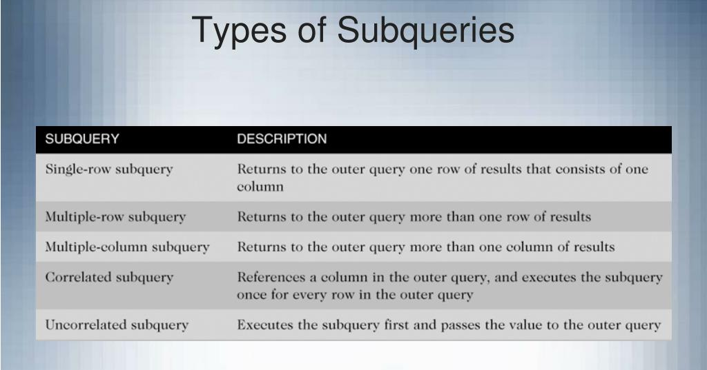

- On the basis of output
- Scalar subqueries: These are the simplest and ideal for comparisons and filtering. They return a single value (e.g., date, number, string). Here's an example of a scalar subquery in a SELECT clause that shows each order ID along with the date of the most recent order.
- Row subqueries: These subqueries return a single row, though that row can have multiple columns. They come in handy when you want to compare values. For example, you can get the lowest-priced products in each category with a row subquery.
- Table subqueries: These can return a set of rows and columns (i.e., a temporary table). They're best for aggregating data or performing complex calculations before retrieving the final results. So, if you want to find customers who've placed orders over $1,000.

- Correlated subqueries: A correlated subquery is a subquery that depends on the outer query for its values.

Select * from emp
Where sal = (select max(sal) from emp);
select * from emp where dept = ( select dept_no from dept where dname = "sales");
select * from emp where deptno = ( select dept_no from dept where dname = "sales" or dname = “accounting”);
select * from emp where dept in ( select dept_no from dept where dname = "sales" or dname = “accounting”);
select * from emp where dept in ( select dept_no from dept where dname = "sales" or dname = “accounting” order by dept_no);
select * from emp where dept in ( select dept_no from dept where dname = "sales" or dname = “accounting”) order by dept_no;
select e_name,sal from emp e where sal > (select sal from emp m e.mgr = m.emp_no);

fetch 8th highest sal?
Select * from
(select sal, dense_rank() over(order by sal desc) as R from emp) Ranked where R = 8;
SELECT product_name, category_id
FROM products
WHERE category_id IN (SELECT category_id FROM categories WHERE parent_category = 'Electronics');
SELECT product_name, price
FROM products
WHERE price > (SELECT AVG(price) FROM products);

SELECT
employee_name,
salary,
(SELECT AVG(salary) FROM employees) as avg_company_salary,
salary - (SELECT AVG(salary) FROM employees) as salary_difference
FROM employees;
SELECT product_name, unit_price
FROM products
WHERE unit_price > (SELECT AVG(unit_price) FROM products);

SELECT product_name, unit_price
FROM products
WHERE category_id IN (
SELECT category_id
FROM categories
WHERE category_name LIKE '%Beverages%');

SELECT category_id, AVG(unit_price) as avg_price
FROM products
GROUP BY category_id
HAVING AVG(unit_price) > (
SELECT AVG(unit_price) FROM products);

SELECT e1.employee_id, e1.employee_name, e1.salary
FROM employees e1
WHERE e1.salary > (
SELECT AVG(e2.salary)
FROM employees e2
WHERE e2.department_id = e1.department_id
);
SELECT product_name
FROM products
WHERE supplier_id NOT IN (
SELECT supplier_id
FROM suppliers
WHERE country = 'Germany');

- Find Employees Who Earn More Than l’'Blake':
  - List the E_name and sal of all employees whose salary is greater than 'Blake's salary.
- Find Employees with the Same Job as 'Jones':
  - List the E_name, job, and sal of all employees who have the same job title as 'Jones', excluding 'Jones' himself.
- Find Employees Who Were Hired After 'Scott':
  - List the E_name and hire_date of employees who were hired after 'Scott'.
- Find Departments with at Least One 'Manager':
  - List the distinct dept_no where at least one employee holds the 'manager' job.
- Find employees who earn the maximum salary in their job role.
- Identify employees whose salary is in the top 2 of their department.
- Find Employees Whose Salary is Greater Than the Average Salary of Their Department:
  - List E_name, sal, and dept_no for employees who earn more than the average salary of their respective departments.
- Find Employees Who Earn more than Salary as Someone in Department 30’s min salary:
  - List E_name, sal, and dept_no for employees who have a salary that matches any salary found in department 30.
- Find Employees Who Report to 'King':
  - List the E_name and job of employees whose manager is 'King'.
- Find Employees Who Have the Lowest Salary in Their Job Category:
  - List E_name, job, and sal for employees whose salary is the minimum salary for their specific job title.
More Subquery Questions (Different Scenarios):
- Employees Hired in the Same Year as 'Ford':
  - Retrieve the E_name, hire_date, and job of all employees who were hired in the same year as 'Ford'.
- Departments with Total Salary Exceeding a Specific Amount:
  - List the dept_no and the total salary for departments where the sum of salaries is greater than $9000
- Employees Who are Not Managers but Have a Salary Greater Than 'Clark':
  - Find the E_name, job, and sal of employees who are not 'manager' but earn more than 'Clark's salary.
- Find Employees Whose Salary and Commission Combination is Unique:
  - List E_name, sal, and comm for employees whose (sal, comm) pair is not found anywhere else in the table (i.e., no other employee has the exact same salary AND commission).
- Employees Who Earn More Than All Clerks:
  - List the E_name and sal of employees who earn a salary greater than the maximum salary of all 'cleark's.
- Employees Who Are Managers in Departments with No Salesmen:
  - Find the E_name of managers who work in departments where there are no 'salesman' job roles.
Find Employees in 'Sales' Department:
- List the E_name, job, and sal of all employees who work in the 'Sales' department.
Find Departments with No Employees:
- List the dname and loc of departments that currently have no employees.
Find Employees Whose Department is Located in 'New York':
- List the E_name, job, and dept_no of employees who work in departments located in 'New York'.
Find Departments Where All Employees Earn More Than 2000:
- List the dname and loc of departments where every single employee's salary is greater than $2000.
Find Employees Who Earn the Highest Salary in Their Department:
- List the E_name, sal, dname, and loc for employees who have the maximum salary within their respective departments.
Find Employees Who Work in Departments That Also Have a 'President':
- List the E_name, job, and dname of employees who are in a department that also contains an employee with the job title 'president'.
Find Departments Where the Average Salary is Above the Overall Average Salary:
- List the dname and loc for departments where the average salary of employees in that department is greater than the average salary of all employees across the company.
List Employees Who Do Not Work in 'Dallas' or 'Chicago':
- Find the E_name, job, and dname of employees whose department is not located in 'Dallas' or 'Chicago'.
Find Departments That Have More Than 3 Employees:
- List the dname and loc of departments that have more than 3 employees.
Employees with Salary Greater Than the Minimum Salary of Any Department in 'Dallas':
- List the E_name, sal, and dname of employees whose salary is greater than the minimum salary of any employee in a department located in 'Dallas'.
- Find Employees in 'Sales' Department:
  - List the E_name, job, and sal of all employees who work in the 'Sales' department.
- Find Departments with No Employees:
  - List the dname and loc of departments that currently have no employees.
- Find Employees Whose Department is Located in 'New York':
  - List the E_name, job, and dept_no of employees who work in departments located in 'New York'.
- Find Departments Where All Employees Earn More Than 2000:
  - List the dname and loc of departments where every single employee's salary is greater than $2000.
- Find Employees Who Earn the Highest Salary in Their Department:
  - List the E_name, sal, dname, and loc for employees who have the maximum salary within their respective departments.
- Find Employees Who Work in Departments That Also Have a 'President':
  - List the E_name, job, and dname of employees who are in a department that also contains an employee with the job title 'president'.
More Subquery Questions (Focus on Clause Usage):
- Display Employee Name, Salary, and Their Department's Location:
  - List E_name, sal, and the loc of the department they belong to.
- Identify Departments with at Least One Employee Earning Over $4000:
  - List the dname and loc of departments where at least one employee has a salary greater than $4000.
- Find Employees Who Are Managers But Not the Highest Paid in Their Department:
  - List the E_name, sal, and dname of employees who are 'manager's but whose salary is not the maximum salary in their department.
- Employees Hired on the Same Date as Any Employee in Department 20:
  - List E_name, hire_date, and dname for employees who were hired on the same date as any employee in Department 20.
- Select all department names which has more number of employees working than 'ACCOUNTING' department
- Select all employee name and salary who are earning more than BLAKE but less than KING
- select all department numbers which has more number of employees than department 10

Set Operations:
Set operators are used to combine or exclude the results of two or more SELECT statement queries into a single result set.
They perform by combining rows from two or more tables as opposed to columns in SQL joins. Set operators are similar to a mathematical operation.
While SQL JOINs tie tables together horizontally (left to right) using columns, UNIONs effectively combine/exclude rows from tables vertically (top to bottom).

There are four fundamental set operators used in SQL:
- UNION – combines two or more result sets without duplicating values.
- UNION ALL – combines two or more result sets including duplicate values
Working of Union
- The tables to be combined must have same number of columns with the same datatype.
- The number of rows need not be same.
Once these criteria are met, UNION operator returns all the rows from multiple tables, after eliminating duplicate rows, as a resultant table.
Note: Column names of first table will become column names of resultant table, and contents of second table will be merged into resultant columns of same data type.
SELECT * FROM table1
UNION ALL
SELECT * FROM table2;
SELECT * FROM table1
UNION
SELECT * FROM table2;

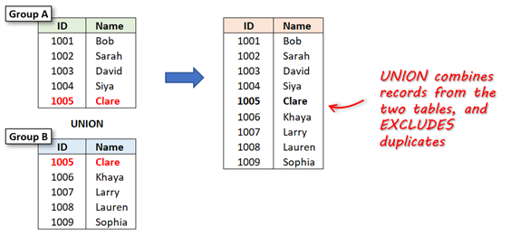
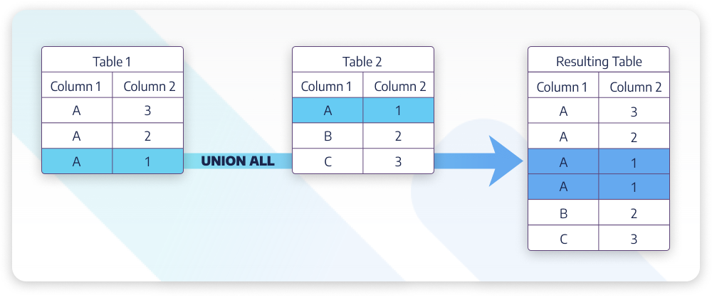
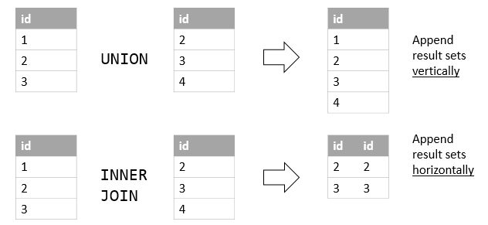

Order by;
You can’t use ORDER BY in individual queries within a UNION unless you use parentheses and limit the scope (e.g., for subqueries). The main ORDER BY goes at the end.
SELECT product, sales FROM domestic_sales ORDER BY sales
UNION
SELECT product, sales FROM international_sales ORDER BY sales;

Instead, use:

SELECT product, sales FROM domestic_sales
UNION
SELECT product, sales FROM international_sales
ORDER BY sales;

The column names in the final result come from the first query. So, in ORDER BY, use the column names or aliases from the first query.

CREATE TABLE IF NOT EXISTS email_subscribers ( subscriber_id INT PRIMARY KEY AUTO_INCREMENT, email VARCHAR(100) NOT NULL UNIQUE, signup_date DATE );
INSERT INTO email_subscribers (email, signup_date) VALUES ('alice@example.com', '2023-01-15'),
('bob@example.com', '2023-02-20'),
('charlie@example.com', '2023-03-10'),
('david@example.com', '2023-04-05'),
('eve@example.com', '2023-05-01'),
('frank@example.com', '2023-06-10');
CREATE TABLE IF NOT EXISTS course_enrollments ( enrollment_id INT PRIMARY KEY AUTO_INCREMENT, email VARCHAR(100) NOT NULL, course_name VARCHAR(100), enrollment_date DATE );
INSERT INTO course_enrollments (email, course_name, enrollment_date) VALUES ('charlie@example.com', 'SQL Basics', '2023-03-15'),
('frank@example.com', 'Python Fundamentals', '2023-06-01'),
('grace@example.com', 'Web Development', '2023-07-20'), ('heidi@example.com', 'Data Science', '2023-08-05'), ('charlie@example.com', 'Advanced SQL', '2023-09-01');

SELECT email, signup_date AS activity_date, 'Email Subscriber' AS type_of_member
FROM email_subscribers
UNION
SELECT email, enrollment_date AS activity_date, 'Course Enrollee' AS type_of_member
FROM course_enrollments;

Key Differences in join & union:
Feature | JOIN | UNION
Combines | Columns (side by side) | Rows (stacked on top)
Needs Relation? | Yes (common column like ID) | No (just same number of columns)
Result Shape | Wider (more columns) | Longer (more rows)
Use Case | Merge related data (e.g., customers + orders) | Combine similar data (e.g., sales from different tables)

When to Use UNION Instead of JOIN?
- When you want to stack rows from multiple tables or queries (e.g., combining sales from different years or regions).
- When the tables don’t have a direct relationship but have similar data.
- When you need to combine results from different queries into one list.
• Use JOIN to combine related data horizontally (adding columns).
• Use UNION to combine similar data vertically (adding rows).

Case statement
The CASE WHEN statement in MySQL allows you to evaluate a list of conditions and return one of several possible result expressions. It is often used in SELECT statements to modify the output based on specific conditions, making it a versatile tool in data retrieval and manipulation.
SELECT
CASE
WHEN condition1 THEN result1
WHEN condition2 THEN result2
ELSE default_result
END AS alias_name
FROM table_name;

- condition1, condition2, …: These are the conditions you want to evaluate.
- result1, result2, …: The values returned when the corresponding condition is true.
- default_result: The value returned if none of the conditions are true. This is optional.
- alias_name: The name of the column in the result set.
Example Usage
Let’s consider an example where we categorize employees based on their salary range.

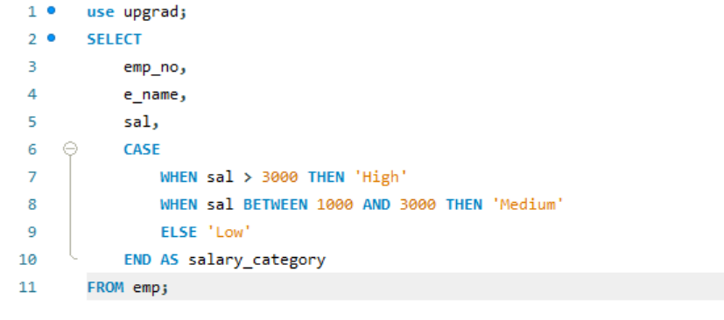
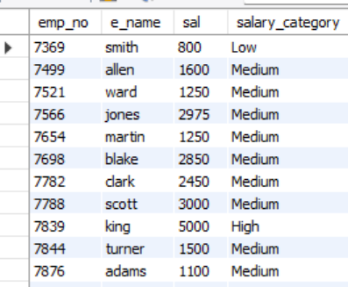

Using CASE WHEN with Aggregation
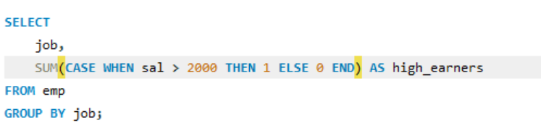
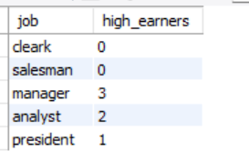
Nested CASE WHEN Statements
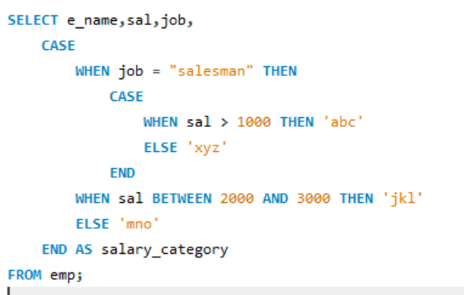
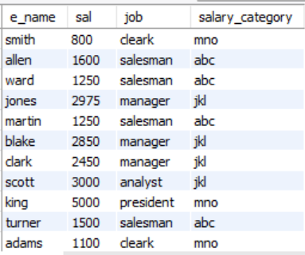
SELECT
customer_id,
customer_name,
total_spent,
CASE
WHEN total_spent > 1000 THEN 'Premium'
WHEN total_spent BETWEEN 500 AND 1000 THEN 'Regular'
ELSE 'Occasional'
END AS customer_segment
FROM customers;

SELECT
student_id,
student_name,
exam_score,
CASE
WHEN exam_score >= 90 THEN 'A'
WHEN exam_score >= 80 THEN 'B'
WHEN exam_score >= 70 THEN 'C'
WHEN exam_score >= 60 THEN 'D'
ELSE 'F'
END AS grade
FROM exam_results;

SELECT
shipment_id,
customer_name,
days_since_shipment,
CASE
WHEN days_since_shipment <= 3 THEN 'On Time'
WHEN days_since_shipment BETWEEN 4 AND 7 THEN 'Delayed'
ELSE 'Very Delayed'
END AS delivery_status
FROM shipments;

Task: Create a new column called Salary_Category that displays:
- 'Low' if sal is less than or equal to 1000
- 'Medium' if sal is between 1001 and 2500 (inclusive)
- 'High' if sal is greater than 2500
Display emp_no, E_name, sal, and the new Salary_Category column
Task: Add a column called Commission_Status that shows:
- 'Receives Commission' if comm is greater than 0
- 'No Commission' if comm is 0
Display E_name, job, sal, comm, and the new Commission_Status column.
Task: Create a column called Role_Dept_Type that returns:
- 'Sales & Marketing' if job is 'salesman' AND dept_no is 30
- 'Management Support' if job is 'manager' AND (dept_no is 10 OR dept_no is 20)
- 'Clerical Staff' if job is 'cleark'
- 'Other' for all other combinations
Display emp_no, E_name, job, dept_no, and the new Role_Dept_Type column.
Objective: Apply a salary adjustment based on job title and commission.
Task: Create a new column called Adjusted_Sal.
- If the job is 'salesman' and comm is greater than 0, add comm to sal.
- If the job is 'analyst', increase sal by 10%.
- For all other jobs, the Adjusted_Sal should be the original sal.
Display E_name, job, sal, comm, and the new Adjusted_Sal column.
Task: Create a new column named Bonus_Amount.
- If an employee was hired in 1981 and their job is 'salesman', give a bonus of 500.
- If an employee was hired before 1981 (i.e., in 1980) and their job is 'cleark', give a bonus of 200.
- For all other cases, the bonus amount should be 0.
Display E_name, hire_date, job, and the Bonus_Amount.
Task: Create a column named Net_Pay.
- If comm is greater than 0, Net_Pay should be sal + comm.
- If comm is 0, Net_Pay should be sal.
Display E_name, sal, comm, and the Net_Pay.
Task: Create a column named Reporting_To.
- If mgr is 7839, display 'Reports to KING (President)'.
- If mgr is 7698, display 'Reports to BLAKE (Manager)'.
- If mgr is 7566, display 'Reports to JONES (Manager)'.
- If mgr is 7782, display 'Reports to CLARK (Manager)'.
- If mgr is 7902, display 'Reports to FORD (Analyst)'.
- If mgr is 7788, display 'Reports to SCOTT (Analyst)'.
- If mgr is 0 (King's manager), display 'No Manager (Top Executive)'.
- For any other mgr value not explicitly listed, display 'Unknown Manager'.
Display emp_no, E_name, mgr, and the Reporting_To column.
Task: Create a column called Dept_Sal_Evaluation.
- If dept_no is 10 AND sal is greater than or equal to 2500, display 'High Earner - Dept 10'.
- If dept_no is 20 AND sal is greater than or equal to 2000, display 'High Earner - Dept 20'.
- If dept_no is 30 AND sal is less than or equal to 1500, display 'Lower Earner - Dept 30'.
- For all other combinations, display 'Standard'.
Display E_name, dept_no, sal, and the Dept_Sal_Evaluation column.

View
view is a virtual table that simplifies data access by storing a predefined query.
It lets users retrieve data without directly accessing the underlying tables, essentially improving security and abstraction.
With MySQL views, you can easily use simplified queries that encapsulate complex SQL logic and make data retrieval sleeker, restrict access to specific data, and limit its exposure to some of the team members, and boost overall readability.
- Virtual Table: Views don't store data. They dynamically generate their content by executing the underlying query whenever they are referenced.
- Logical Abstraction: They provide a simplified logical representation of your data, hiding the complexity of the underlying tables and joins.
- Based on a SELECT statement: Every view is defined by a SELECT statement. This statement can be as simple or as complex as needed.
Why Use Views?
Simplification of Complex Queries:
- You can create a view that joins multiple tables, applies filters, and performs calculations. Users or applications can then query this view directly, without needing to understand the underlying table structure or the intricacies of the join conditions.
- Example: A view named CustomerOrders could combine data from Customers, Orders, and OrderDetails tables, presenting a unified view of customer order information.
Security:
- Views can be used to restrict access to specific rows and/or columns of a table. You can grant a user SELECT privileges only on a view, even if they don't have direct access to the underlying tables.
- Example: Create a view EmployeeSalaries_Confidential that excludes the salary column, and grant access to this view to most employees, while only granting access to the full Employees table to HR personnel.
Data Abstraction and Independence:
- If the underlying table structure changes (e.g., a column is renamed, or a table is split), you might be able to modify the view definition to accommodate these changes without affecting the applications that rely on the view. This provides a layer of data independence.
- Example: If you rename a column cust_name to customer_full_name in the Customers table, you can update the view definition to reflect this change. Applications querying the view would still see the cust_name column (as defined in the view) and wouldn't need to be modified.
Consistency and Reusability:
- A complex query defined once in a view ensures that everyone using that view is getting consistent data based on the same logic. This promotes code reusability and reduces the chance of errors from repeated query writing.
select * from emp;

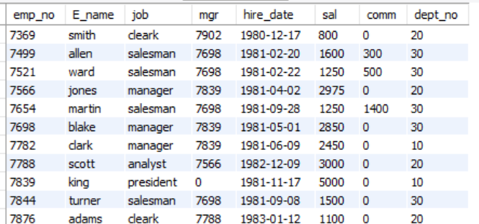

select emp_no, e_name, job from emp;

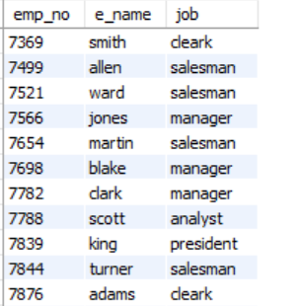
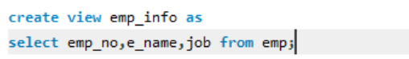
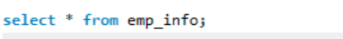
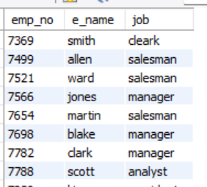
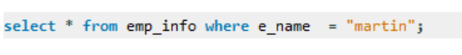
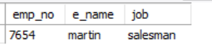
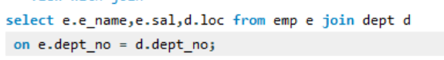
join
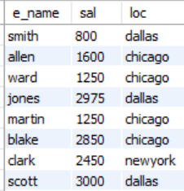
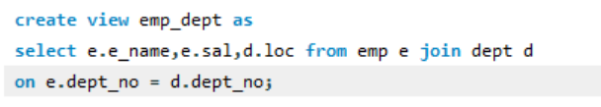
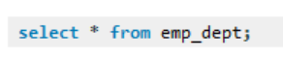

modifying view
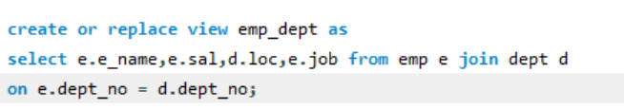

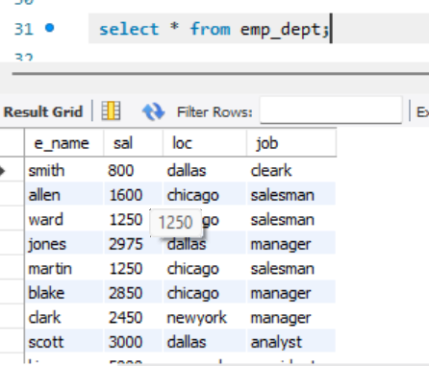
Conditions for an Updatable View:
A view is updatable if and only if all of the following conditions are met:
- No Aggregate Functions: The SELECT statement defining the view does not contain aggregate functions (SUM(), COUNT(), AVG(), MIN(), MAX()).
- No DISTINCT: The SELECT statement does not contain DISTINCT.
- No GROUP BY or HAVING: The SELECT statement does not contain GROUP BY or HAVING clauses.
- No UNION or UNION ALL: The SELECT statement does not contain UNION or UNION ALL.
- Single Base Table (for INSERT and DELETE): For INSERT and DELETE operations, the view must reference only one base table. For UPDATE operations, it can reference multiple tables through joins, but any column being updated must map directly to a column in one of the underlying base tables.

Why?
- INSERT: When you INSERT into a view, the database needs to know which underlying table to add the new row to. If the view is based on a JOIN of two tables, where would the new row go? Into Table A? Table B? Both? This ambiguity makes INSERT into joined views generally impossible.
- DELETE: Similarly, when you DELETE from a view, the database needs to identify which specific row in which specific base table(s) should be removed. If the view is a JOIN, deleting a "row" from the view might mean deleting parts of rows from multiple tables, which is not how DELETE operations work on a fundamental level. DELETE operates on entire rows of a single table.

- Create a view named V_MANAGERS that lists the emp_no, E_name, and hire_date of all employees who are managers.
- Create a view named V_EMP_DEPT_INFO that combines information from the emp table and a dept table . The view should show emp_no, E_name, job, sal, and D_name for all employees.
- Create a view named V_SALES_STAFF that shows the emp_no, E_name, job, and sal for all employees whose job is 'salesman'.
- Create a view named V_CLERKS that includes emp_no, E_name, and sal for all employees whose job is 'cleark'. Try to delete 'JAMES' from this view.
- Create a view named V_ANALYST_MANAGERS that shows the emp_no, E_name, and job of all employees who are either 'analyst' or 'manager'.
- Create a view named V_SALES_STAFF that shows the emp_no, E_name, job, and sal for all employees whose job is 'salesman'.
- Can you insert a new employee directly into the V_SALES_STAFF view (7999, 'Kel', 'IT-HEAD', 1800).

Key Considerations and Limitations for Updatable Views:
When you insert data into a view, you are not actually inserting data "into the view" itself. Instead, you are inserting data into the underlying base table(s) that the view is built upon. This means the view must meet certain criteria to be "updatable" (meaning you can insert, update, or delete data through it).
Here are the most common conditions for a view to be updatable:
- Single Base Table: The view must be derived from a single base table. If your view involves joins, UNION, UNION ALL, or multiple tables in its FROM clause, it is generally not directly updatable for inserts.
- No Aggregate Functions:
- An aggregate produces one summary value from many rows.
- Example: SELECT department, AVG(salary) FROM employees GROUP BY department
- One row in the view may represent 50 (or 500) real rows in the employees table.
- If you try UPDATE view SET avg_salary = 6000, MySQL has no idea:
- Which original rows to change?
- How to distribute the new value among them?
- There is simply no unique mapping → non-updatable.
- No GROUP BY Clause: The SELECT statement defining the view cannot contain a GROUP BY clause.
• GROUP BY collapses multiple rows into a single group row.
• The view no longer shows individual base-table rows; it shows groups.
• Updating a group row would require deciding how to modify (or split) many original rows — which is ambiguous and potentially destructive.
• Result: the required 1:1 relationship disappears → non-updatable.
- No DISTINCT Keyword:
• DISTINCT removes duplicate rows, so the view may contain fewer rows than the base table.
• A single row in the view may correspond to several identical rows in the base table.
• Updating or deleting that view row leaves MySQL unsure which (or how many) base-table rows should be affected
- No Derived Columns (Calculated Columns):
• Example: SELECT emp_id, salary * 1.1 AS new_salary FROM employees
• The column new_salary does not exist in the base table; it is computed on the fly.
• There is nothing physical to update.

Core principle (official MySQL rule)
“For a view to be updatable, there must be a one-to-one relationship between the rows in the view and the rows in the underlying table.”
Any construct that aggregates, de-duplicates, groups, or computes values destroys that relationship, so the view is marked non-updatable.

Cte
Common Table Expressions (CTEs)
CTEs are defined using the WITH keyword, followed by a query that generates the result set. CTEs enable user to more easily write & maintain complex queries via increased readability & simplification.
CTEs allow you to break down complex queries into simpler, more readable parts.
A CTE can be referenced multiple times within the same query, reducing redundancy.
if I want to see the employees who have salary more than avg salary?
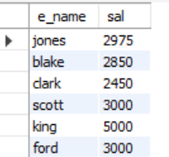
If I want to see e_name, sal, avg_sal of employee who have sal > avg(sal)?
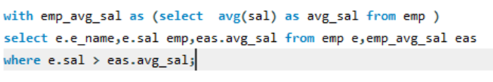
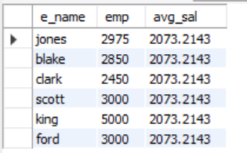
- List each employee's E_name, job, sal, comm, and their Total_Compensation (salary + commission).
- Get the E_name, job, and hire_date of all employees who were hired in the year 1981.
- For each distinct job title, find the job title, the Total_Employees in that job, and the Total_Salary paid to employees in that job.
- Find employees who were hired before their direct manager. Display the employee's E_name, hire_date, their manager's E_name, and the manager's hire_date.
- Find the dept_no and Number_of_Employees for departments that have more than 3 employees.
- Identify all 'SALESMAN' employees who earn a salary of 1500 or more. Display their E_name, sal, and comm.

User Define Function
- SUM(), AVG(), COUNT(): Aggregate functions for calculations on groups of rows.
- CONCAT(): Joins multiple strings together.
- UPPER(), LOWER(): Convert strings to uppercase or lowercase.
- NOW(): Returns the current date and time.
- SUBSTRING(): Extracts a portion of a string.
- ROUND(): Rounds a number.
Built-in functions are typically designed to perform common, frequently used operations.
These functions is already written and compiled into the core of the language or system by its developers. You don't need to write the function's logic yourself.
A **User-Defined Function (UDF)** in MySQL is a custom function you create to perform specific tasks in your database. Think of it like a reusable piece of code that you can call whenever you need to do a particular calculation or process in your SQL queries.
- What it does: A UDF lets you define your own logic (like calculations, string manipulations, or custom rules) and use it in your SQL queries, just like built-in MySQL functions (e.g., `SUM()`, `UPPER()`).
- Why use it: It saves time by letting you reuse complex logic without rewriting it every time. It also makes your queries cleaner and easier to maintain.
- How it works: You write the function using SQL or a programming language like C/C++ (for advanced cases), store it in the database, and then call it in your queries.

### Key Points:
1. Created by the user: You define the function with a name, input parameters (if needed), and what it returns.
2. **Stored in the database**: Once created, it’s saved in MySQL and can be used in `SELECT`, `WHERE`, or other SQL statements.
3. **Types of UDFs**:
- **SQL-based UDFs**: Written in SQL for simpler tasks (e.g., calculating a discount or formatting data).
- **Compiled UDFs**: Written in languages like C/C++ for complex tasks (e.g., advanced math or external data processing).
4. **Example**:
Suppose you want a function to calculate the square of a number. Instead of writing the formula repeatedly, you create a UDF called `Square` and use it like this:
```sql
SELECT Square(5); -- Returns 25
```

### Basic Syntax (for SQL-based UDF):
```sql
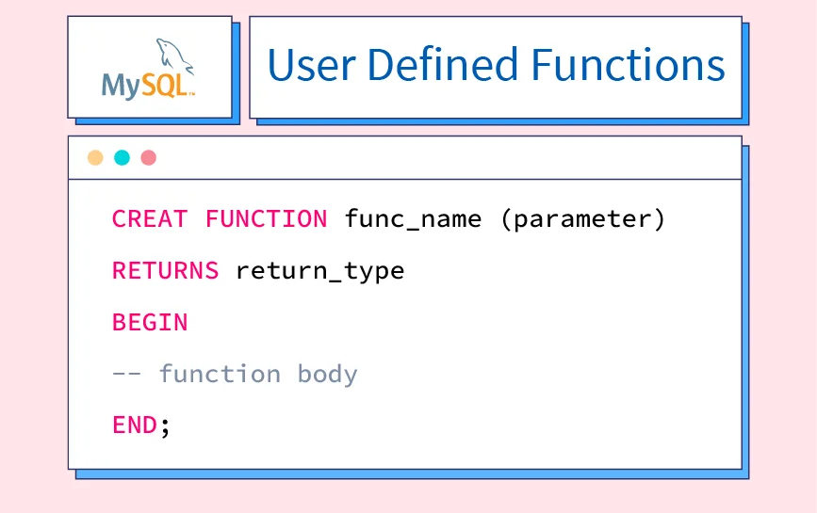```

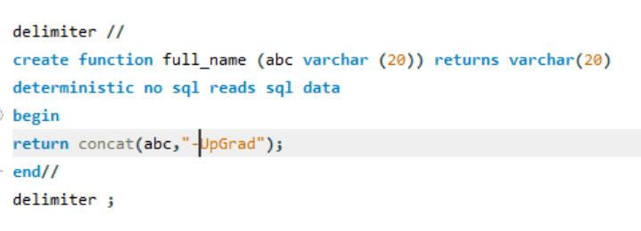

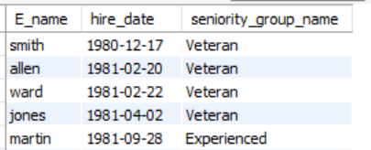
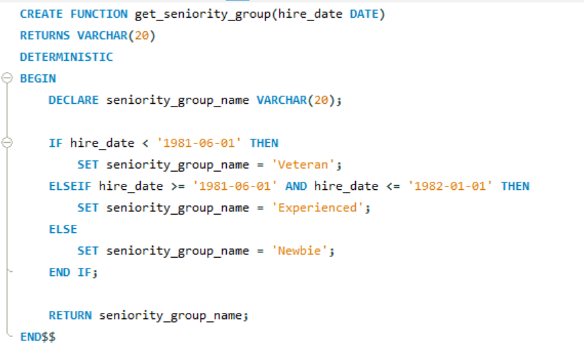

Delimiter $$, //
Function_name()
Parameter
Returns
Begin
`Declare - Variable name
Return - Variable name
End//
Delimiter;

### Benefits:
- Reusability: Use the same function across multiple queries.
- Simplicity: Keeps your queries short and readable.
- Consistency: Ensures the same logic is applied everywhere.

### Notes:
- UDFs in MySQL are less common for simple tasks since MySQL has many built-in functions.
- For complex UDFs (e.g., in C/C++), you need to compile and install them, which is more technical.
- Always test UDFs to ensure they work correctly and don’t slow down your database.

- Question: Design a UDF named format_full_name that takes E_name as input and the job title. The UDF should return a formatted string like "Employee: Smith, Job: Clerk".
- Question: Design a UDF named calculate_adjusted_salary that takes an employee's sal and comm as input. It should return the sal plus comm, but if comm is NULL or 0, it should assume comm is 10% of sal for the calculation. Write a SQL query to show E_name, original sal, and the adjusted_salary for all employees.
- Design a UDF named mask_dept_name that takes a dname as input. If the dname is 'accounting', it returns 'FINANCE'; if it's 'research', it returns 'R&D'; otherwise, it returns 'GENERAL_DEPT'. Write a SQL query that selects E_name and their masked_dept_name (using the UDF) by joining emp and dept tables.
- Design a UDF named get_years_of_service that takes an hire_date as input and returns the number of full years an employee has served. Write a SQL query to display E_name, hire_date, and their years_of_service.
- Design a UDF named get_seniority_group that takes an hire_date. It should return:
- 'Veteran' if hired before '1981-06-01'
- 'Experienced' if hired between '1981-06-01' and '1982-01-01'
- 'Newbie' if hired after '1982-01-01'
- Write a SQL query to list employees (E_name, hire_date) and their respective seniority_group.
- Design a UDF named get_salary_band that takes an employee's sal as input. It should return:
- 'Low' if sal < 1000
- 'Medium' if sal is between 1000 and 2500 (inclusive)
- 'High' if sal > 2500
- Write a SQL query to display E_name, sal, and their corresponding salary_band.
- Write a SQL query to count the number of employees in each salary_band.
- Design a UDF named get_hire_season that takes a hire_date. It should return 'Winter' (Dec-Feb), 'Spring' (Mar-May), 'Summer' (Jun-Aug), or 'Autumn' (Sep-Nov).
- Write a SQL query to list employees (E_name, hire_date) and their hire_season.
- Write a SQL query to count how many employees were hired in each hire_season.

Stored Procedures
A stored procedure is basically a pre-written SQL code block that you store inside the MySQL database itself. It's like saving a script or a mini-program directly within your database.
Reusability
If you have a complex query or a series of operations you perform often (e.g., adding a new customer, updating an order, generating a report), you write it once as a stored procedure. Then, instead of typing out all that SQL every time, you just "call" or "execute" the stored procedure by its name.
Performance
When you first execute a stored procedure, MySQL compiles it (optimizes it) and stores that compiled version. Subsequent calls to the same procedure are faster because MySQL doesn't have to parse and compile the code again. It just executes the pre-optimized version. This can lead to significant performance improvements for frequently run operations.
Encapsulation
Stored procedures allow you to break down complex database operations into smaller, logical units. This makes your database code more organized, easier to understand, and simpler to maintain.
DELIMITER // -- A temporary change to the delimiter
CREATE PROCEDURE GetCustomerDetails(IN P_customer_id INT)
BEGIN
SELECT * FROM Customers WHERE customer_id = P_customer_id;
END //
DELIMITER ; -- Change delimiter back to semicolon

CALL GetCustomerDetails(123); -- Executes the procedure for customer ID 123
With single statement

With multiple statement
Stored Procedure
With input parameter

With output parameter

With output parameter
  - - MySQL stored procedure primarily when you want the procedure to return a single, scalar value.
  - If you need to "return" a single value from a procedure, an OUT parameter is the mechanism to achieve that.
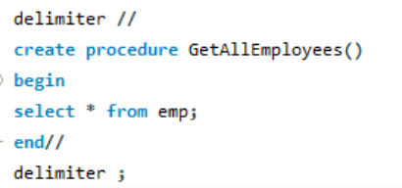
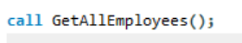

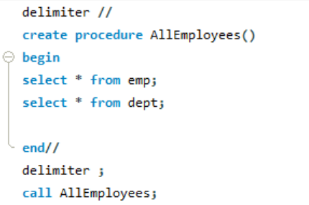
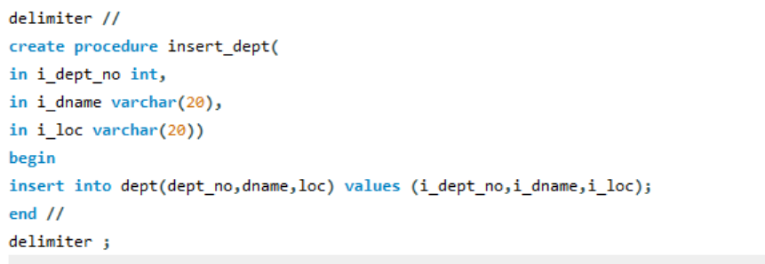
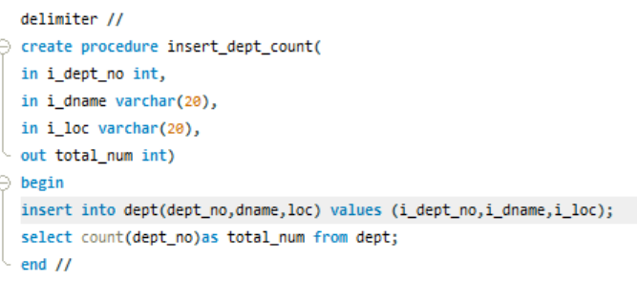

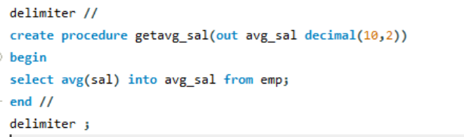
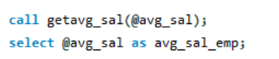

Why we use “@” ?
To Store the Output: A stored procedure's OUT parameter doesn't directly return a value that you can immediately use in a SELECT statement like a function. Instead, it populates a variable that you pass to it. The @variable_name syntax allows you to create a temporary storage location in your current MySQL session.

To get the values returned by the OUT parameters, you need to use user-defined variables (prefixed with @) when calling the procedure, and then select those variables.
- Create a stored procedure named GetAllEmployees that simply retrieves all columns for all employees from the emp table.
- Create a stored procedure named GetEmployeeById that takes an employee_number as an input parameter and returns all details for that specific employee.
- Create a stored procedure named GetEmployeesByDepartment that takes a department_number as an input parameter and returns the emp_no, E_name, and job for all employees belonging to that department.
- Create a stored procedure named UpdateEmployeeSalary that takes an employee_number and a new_salary as input parameters. The procedure should update the sal column for the specified employee with the new_salary.
- Create a stored procedure named GetEmployeesByJobAndDept that takes a job_title (VARCHAR) and a department_number (INT) as input parameters. It should return the emp_no, E_name, job, and sal for all employees matching both criteria.
- Create a stored procedure named GetMaxSalaryInDepartment that takes a department_number (IN) and returns the highest salary found within that department
- Create a stored procedure named GetEmployeeCountInDepartment that takes a department_number as an input parameter and returns the count of employees in that department using an output parameter.
- Create a stored procedure named GetEmployeeAndDepartmentName that takes an employee_number as input. It should return the employee's E_name and their corresponding dname (department name). This will require joining the emp and dept tables.
- Create a stored procedure named AddEmployee that takes all necessary employee details as input parameters. The procedure should insert a new record into the emp table.
- Create a stored procedure named GetEmployeeCommissionStatus that takes an employee_number (IN) and returns a text message (OUT) indicating their commission status:
- "Has Commission" if comm is greater than 0.
- "No Commission" if comm is 0 or NULL.
- Create a stored procedure named GetTotalSalaryByDepartment that takes a department_number (IN) and returns the sum of salaries for all employees in that department (OUT).
- Create a stored procedure named GetAverageSalaryByJob that takes a job_title (IN) and returns the average salary for all employees with that job title (OUT).
- Create a stored procedure named DoesEmployeeExist that takes an employee_number (IN) and returns a boolean-like value (OUT) indicating whether an employee with that emp_no exists in the emp table. Use “YES” for exists, “NO” for does not exist.
- Create a stored procedure named GetEmployeeTotalCompensation that takes an employee_number (IN) and returns the total compensation (salary + commission) for that employee (OUT).
- Create a stored procedure named GetManagerName that takes an employee_number (IN) and returns the name of their manager (OUT).
- If the employee has no manager (e.g., KING, whose mgr is 0 or NULL if you change it), or if the manager's emp_no is not found, return NULL or a descriptive string like "No Manager Found".
- Create a stored procedure named GetEmployeeDepartmentDetails that takes an employee_number (IN) and returns two separate output parameters: the department_name (OUT) and the department_location (OUT) for that employee's department.

Index
What are indexes? Why are they important?
Index is a data structure provides quick access to data, optimize the speed of your qurey.
Indexes are like the signs in a movie hall that help you find your seat without having to search the whole .
A primary key is a constraint that imposes uniqueness on a column or set of columns, while a clustered index determines the physical order of the data in the table.
In a MySQL database, your data is stored in tables (like a giantspreadsheet). Each table has rows (like individual entries) and columns (like different pieces of information, e.g., name, age, address).


When you ask MySQL to find specific data (e.g., "Find all users named 'John whick'"), without an index, MySQL has to go through every single row in that table, one by one, and check if the name is 'John whick'. This is called a full table scan, and it can be very slow, especially for large tables.
Index is like a pointer.

This is where indexes come in:
You can create an index on one or more columns in your table. When you create an index, MySQL essentially builds a separate, sorted list of the values in that indexed column(s) along with pointers to where the actual data for those values is located in the main table.
When you use an index:
When you perform a query that filters or sorts data based on an indexed column, MySQL can use its internal "index" to quickly find the relevant rows without having to scan the entire table. It's like it goes directly to the "page" where the data it needs is located.

Key benefits of using indexes:

- Faster Data Retrieval (SELECT queries): This is the primary benefit. Queries that use WHERE clauses, ORDER BY clauses, or JOIN conditions on indexed columns will execute much quicker.

- Faster Sorting: If you frequently sort your data by a particular column, an index on that column can significantly speed up the sorting process.
- Enforcing Uniqueness: Indexes can also be used to enforce uniqueness constraints, ensuring that no two rows have the same value in a specific column (e.g., a unique email address for each user).



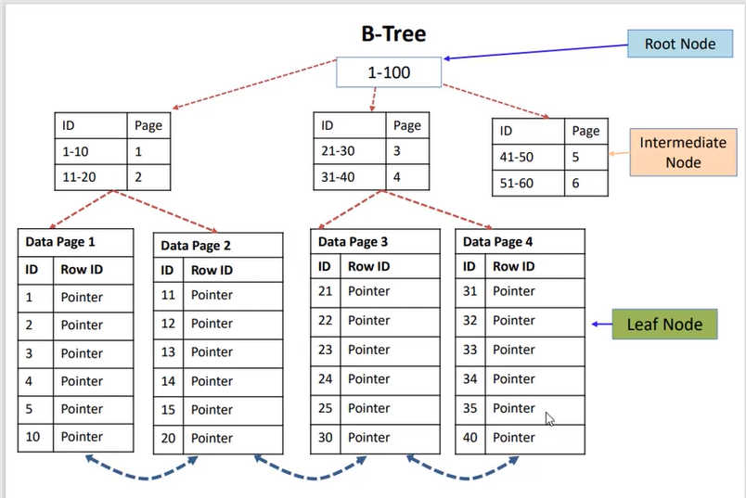

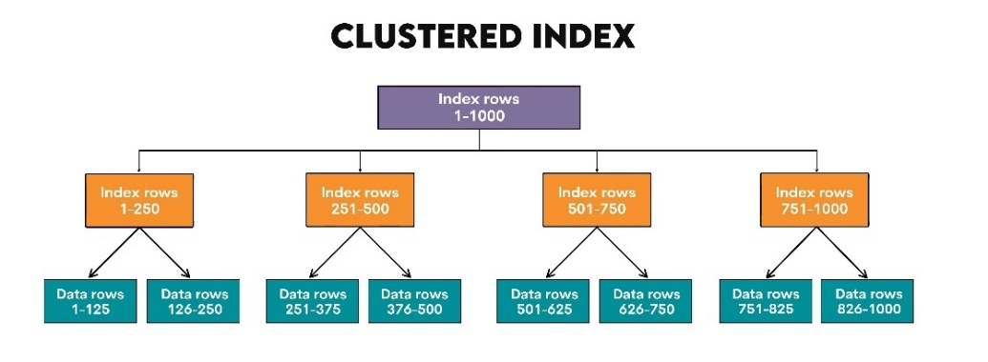

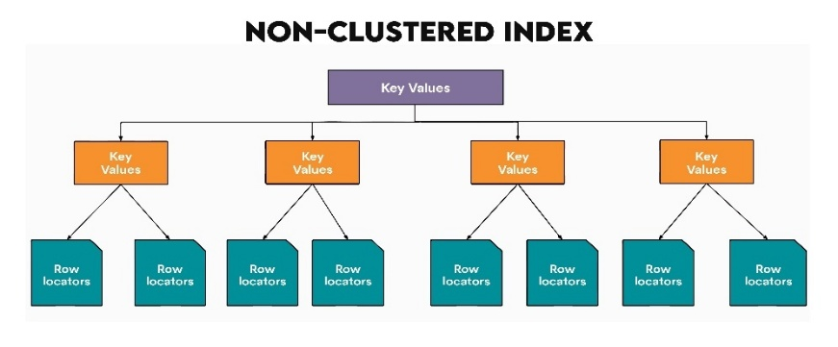

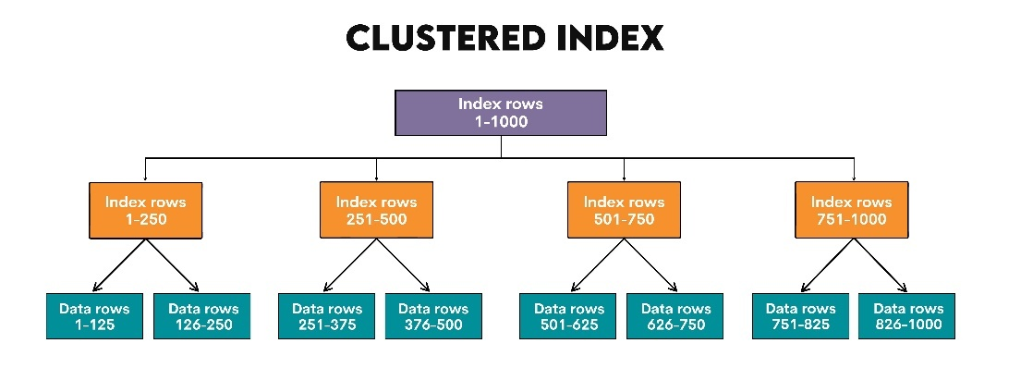

If a table does not have a clustered index, it's often referred to as a "heap." In this scenario, the rows are not stored in any particular physical order.
For a non-clustered index on a heap, the pointer is usually a Row Identifier (RID). This RID directly points to the physical location of the data row on disk.

Who is better
There's no definitive "better" between clustered and non-clustered indexes. Both are powerful tools for improving database performance, but they serve different purposes and have different trade-offs. The "better" choice depends entirely on your specific data, the types of queries you run most frequently, and your workload.
Clustered Index:
- Extremely fast for range queries: Because the data is physically sorted, retrieving a range of values (e.g., all orders from January, all customers with names A-F) is incredibly efficient.
- Fast for retrieving entire rows: Once the database finds the index entry, it's already at the data row, so no extra "hop" is needed.
- Efficient for ORDER BY clauses: If you frequently sort your results by the clustered index column, the data is already sorted, saving the database the effort of sorting.

Non-Clustered Index:
- Multiple per table: You can create many non-clustered indexes on different columns or combinations of columns, optimizing for various query patterns.
- Fast for specific lookups: Excellent for WHERE clauses that filter on specific values in the indexed columns.
- Flexibility: Can be created on any column, regardless of its data type or volatility.

When to use which:
Choose a Clustered Index when:
- You have a natural primary key that is unique, stable (rarely changes), and ever-increasing (like an auto-incrementing ID or a datetime column for logs). This is often the default choice and a good one for many transactional tables.
- You frequently perform range queries (BETWEEN, >, <) on the column.
- You often retrieve data sorted by that column.
- You need to retrieve the entire row for queries based on that column.
- The table is frequently joined on that column to other tables.

Create table ----
Create index ---
Create index index_name on table_name (col_name);

